# C O V E N T R Y

# U N I V E R S I T Y

Faculty of Engineering, Environment and Computing

School of Computing, Electronics and Mathematics

MSc Data Science

7150CEM

Data Science Individual Research Report

Optimizing Fire Brigade Response Times Using Machine Learning

Author: Ndubuaku Ekwueme

SID: 13999560

1st Supervisor:

2nd Supervisor:

Submitted in partial fulfilment of the requirements for the Degree of Master of Science in

Data Science

Academic Year: 2023/24

# Declaration of Originality

I declare that this project is all my own work and has not been copied in part or in whole from any other source except where duly acknowledged. As such, all use of previously published work (from books, journals, magazines, internet etc.) has been acknowledged by citation within the main report to an item in the References or Bibliography lists. I also agree that an electronic copy of this project may be stored and used for the purposes of plagiarism prevention and detection.

**Statement of copyright**

I acknowledge that the copyright of this project report, and any product developed as part of the project, belong to Coventry University. Support, including funding, is available to commercialise products and services developed by staff and students. Any revenue that is generated is split with the inventor/s of the product or service. For further information please see [www.coventry.ac.uk/ipr](http://www.coventry.ac.uk/ipr) or contact [ipr@coventry.ac.uk](mailto:ipr@coventry.ac.uk).

**Statement of ethical engagement**

I declare that a proposal for this project has been submitted to the Coventry University ethics monitoring website (https://ethics.coventry.ac.uk/) and that the application number is listed below (Note: Projects without an ethical application number will be rejected for marking)

Signed: Date: 01/08/2024

Please complete all fields.

|  |  |
| --- | --- |
| First Name: | Ndubuaku |
| Last Name: | Ekwueme |
| Student ID number | 13999560 |
| Ethics Application Number | P177819 |
| 1st Supervisor Name |  |
| 2nd Supervisor Name |  |

**This form must be completed, scanned and included with your project submission to Turnitin. Failure to append these declarations may result in your project being rejected for marking.**

# ABSTRACT

The optimization of fire brigade response times is a critical concern for public safety and efficient resource allocation. This research project explores the application of machine learning (ML) techniques to predict and optimize fire brigade response times in London. By analyzing a comprehensive dataset from the London Fire Brigade (LFB), encompassing 713,368 fire incidents from 2018 to 2024, the study identifies key factors influencing response times and develops predictive models using various ML algorithms. The research reveals that location-based features, temporal variables, and incident types significantly impact response times. Among the ML models evaluated, XGBoost consistently outperforms others, achieving the lowest Root Mean Squared Error (RMSE) of 0.5824 and the highest R-squared (R^2) value of 0.6017 after capping outliers and removing null values for the second pump attendance time, highlighting its potential for optimizing dispatch and routing decisions. The study also addresses challenges related to data preprocessing, missing values, and model interpretability, offering insights for future research and practical implementation. By leveraging Machine Learning (ML)-driven predictions and data-driven decision-making, fire brigade services can enhance their preparedness, optimize resource allocation, and ultimately reduce response times, leading to improved public safety and more efficient emergency response operations.

Table of Contents

Title Page 1

Declaration of Originality 2

ABSTRACT 3

Acknowledgements 6

List of Tables 7

List of Figures 7

List of Equations 8

1. INTRODUCTION 9

1.1 BACKGROUND 9

1.2 Problem Statement 10

1.3 Research Questions 10

1.4 Research Objectives 10

1.5 Significance of the study 11

1.6 Overview of this report 11

2. LITERATURE REVIEW 12

2.1 Factors Influencing Emergency Response Times 12

2.2 Current Optimization Methods 13

2.3 The Emergence of Machine Learning 14

2.3.1. Machine Learning 15

2.3.2. Machine Learning Techniques for Optimizing Fire Brigade Response Time 17

2.3.3. Predictive Modelling for Enhanced Preparedness 17

2.3.4. Optimizing Dispatch and Routing Decisions 17

2.3.5. Enhancing Decision-Making and Resource Allocation 18

2.3.6. Machine Learning: A Multifaceted Tool for Optimization 18

2.4 Machine Learning Algorithms for Prediction 18

2.4.1. Neural Networks 19

2.5 Case Studies and Real-World Applications 19

2.5.1. Fire Susceptibility and Prevention 19

2.5.2. Emergency Response Time Optimization 20

2.5.3. Fire Brigade Operations and Resource Allocation 21

2.6 Gaps in Literature 25

3. METHODOLOGY 27

3.1 Research Design 27

3.2 Dataset 27

3.3 Data Processing 30

3.4 Feature Scaling 30

3.5 Machine Learning Models 31

3.6 Model Evaluation metrics 34

3.7 Model Validation and Hyperparameter Tuning 35

4. RESULTS 37

4.1 Exploratory Data Analysis (EDA) 37

4.2 MODEL RESULT 43

4.3 Analysis and Interpretation 50

5. CONCLUSION 51

5.1 Achievements 51

5.2 Limitations 51

5.3 Future Research 52

6. PROJECT MANAGEMENT 53

6.1 Gantt Chart 53

6.2 Project Summary Meetings 53

6.3 Risk Management 55

7. SOCIAL, LEGAL, ETHICAL AND PROFESSIONAL CONSIDERATIONS 57

BIBLIOGRAPHY AND REFERENCES 58

APPENDIX A: Certificate Of Ethical Approval 65

APPENDIX B: Project Presentation 66

APPENDIX C: Project Plan 71

APPENDIX D: Python Code 72

# Acknowledgements

I extend my heartfelt gratitude to my supervisor, Ms. Eziamaka Nwakile, for her unwavering guidance and support throughout this endeavour. Her insightful feedback and unwavering encouragement were instrumental in shaping and refining this research.

I am deeply indebted to my parents for their boundless love and sacrifices, affording me the invaluable opportunity to pursue this degree and embark on this research journey. Their steadfast belief in my abilities has been a constant source of inspiration.

To my beloved family, thank you for your unwavering love and encouragement. Your support has been the bedrock upon which this accomplishment stands.

I also wish to express my sincere appreciation to my brother, Ogbonna Ekwueme, whose knowledge and expertise have significantly enriched this project. His insights and contributions have been invaluable.

Finally, I humbly acknowledge the grace and guidance of God, which provided me with the strength and wisdom to complete this endeavour.

# List of Tables

Table 1: Research papers summary

Table 2. LFB Dataset

Table 3: Results with the Whole Dataset (Treating Missing Values with Median and No Shuffle)

Table 4: Results After Removing All Null Values

Table 5: Results After Removing Null Values and Location Columns

Table 6: Results After Capping Outliers and Removing Null Values

Table 7: Removing Null Values for Second Pump Attendance Time

Table 8: Removing Null Values for Second Pump Attendance Time and dropping location columns

Table 9: Results After Capping Outliers and Removing Null Values for Second Pump Attendance Time

Table 10: hyperparameter tuning using Randomized Search CV and removing null values for the second pump attendance time

Table 11: Summary Meeting

Table 12: Risk Management

# List of Figures

Figure 1: Elements of Machine Learning

Figure 2: A diagram of a machine learning process

Figure 3: population size of London

Figure 4: number of incidents by type of property

Figure 5: average response time by property type

Figure 6: average response time by call hour

Figure 7: fire incident frequency and type throughout the day

Figure 8: fire incidents across months of the year

Figure 9: average response time for different incident groups

Figure 10: distribution of first pump arrival times

Figure 11: Box plot before capping and after capping outliers

Figure 12: Gantt chart

# List of Equations

Equation 1: The Multilayer Perceptron (MLP) Network

Equation 2: Mean Squared Error (MSE)

Equation 3: Root Mean Squared Error (RMSE)

Equation 4: Mean Absolute Error (MAE)

Equation 5: R-squared (R²)

# INTRODUCTION

The rapid and effective response of fire brigades to emergencies is crucial for protecting public welfare and minimizing the impact of calamities. Nevertheless, maximizing reaction times is a complex task due to various factors such as traffic conditions, resource allocation, and event prediction, which provide substantial hurdles. Recent breakthroughs in machine learning (ML) provide hopeful answers to tackle these problems and enhance the effectiveness of emergency response systems. Machine learning methods can be utilized to improve several areas of fire brigade operations.(Kim & Muminov, 2023) Predictive models can be trained to anticipate the probability and intensity of occurrences, enabling fire departments to strategically allocate resources and manpower in preparation for anticipated emergencies.The citation "(Pettet et al., 2022)" refers to a source written by Pettet and colleagues in the year 2022. Incorporating real-time data from sensors, traffic monitoring, and emergency communications into machine learning algorithms allows for the dynamic routing and dispatching of fire trucks. This enables them to navigate through congestion and optimize journey time (Kadir et al., 2021). By incorporating machine learning into fire brigade response systems, there can be a substantial enhancement in incident detection, allocation of resources, and coordination of emergency response. By harnessing the potential of data-driven decision-making, fire departments may enhance their decision-making process, optimize resource allocation, and ultimately deliver expedited and dependable emergency services to their communities.

## BACKGROUND

The London Fire Brigade (LFB) is among the largest firefighting and rescue organizations globally. It addresses a variety of significant occurrences such as residential fires, fires in non-residential buildings, and acts of arson. Additionally, it addresses terrorist incidents, flooding, and road traffic collisions. Amidst the pandemic, the LFB took on the responsibility of operating ambulances to assist the London Ambulance Service and attended to Covid-19 fatalities within the local community (Nicole Winchester, 2022). In the field of firefighting, every single second holds significant importance. The prompt arrival of a fire brigade at a site increases the possibility of saving lives, reducing damage, while preventing a small fire from escalating into a large and destructive blaze. Studies has demonstrated a distinct correlation between the speed of response and the severity of a fire. Even a brief delay of a couple of minutes can determine whether a kitchen fire is successfully controlled or if a whole structure is engulfed by flames. The optimization of response times is not solely concerned with logistics, but also with the protection of lives and property.

The fire crews are facing increased pressure due to the expanding urbanization and higher population density. Consider the London Fire Brigade as an example. Each year, fire departments face a continuous flow of emergencies. These incidents might range from large-scale fires and vehicle accidents to medical emergencies or spills of dangerous substances. Managing a variety of ongoing occurrences involves the implementation of a sophisticated system for allocating resources and dispatching firemen.

## Problem Statement

Matt Parr, an HM Inspector of Fire and Rescue Services, stated that the London Fire Brigade has numerous areas in need of improvement. It is imperative to enhance the efficacy of public protection by strengthening fire regulations and improving emergency response to fires and other crises (Booth, 2019). The existing fire brigade response strategies are often limited by conventional preparation and responsive actions, which can lead to significant delays during crucial situations. The intricate nature of metropolitan settings, combined with unexpected traffic patterns, intensifies these issues even further. There is a pressing need for more advanced, data-driven methods to enhance response times and optimize the entire delivery of emergency services. Through the application of machine learning, fire brigade operations have the potential to undergo a significant transformation. Through systematic analysis of vast past emergency datasets, along with geographical data, machine learning algorithms can accurately predict potential risks. This predictive capability paves the way for a comprehensive overhaul of how fire brigades prepare for and respond to emergencies.

## Research Questions

1. What Factors Most Significantly Influence Fire Brigade Response Times?
2. How Can Machine Learning Models be used to Optimize Fire Brigade Dispatch and Routing?
3. What are the Trade-Offs Between Different Machine Learning Models in Terms of Accuracy and Computational Efficiency?

## Research Objectives

1. Develop Predictive Models for Fire Brigade Response Times Using Machine Learning: Create machine learning models that can accurately predict response times based on historical data, real-time factors, and geographical information.
2. Identify Key Factors Influencing Response Times and Develop Strategies for Optimization: Analyse the data to uncover the most significant variables affecting response times and propose actionable strategies for improvement.
3. Evaluate and Compare the Performance of Different Machine Learning Algorithms: Assess various machine learning algorithms to determine which provides the best balance of accuracy and computational efficiency for predicting response times.

## Significance of the study

This research has the potential to significantly transform fire brigade operations and enhance public safety. By utilizing machine learning to predict high-risk areas and optimize dispatch and routing procedures, the fire brigade can significantly reduce response times. This will not only save lives and minimize property damage but also contribute to a more efficient use of resources, ultimately reducing the overall cost of fire brigade operations. The data-driven approach promoted by this research will empower the fire brigade to make more informed decisions, moving away from intuition-based strategies towards evidence-based practices. The predictive models developed will enable proactive resource allocation, ensuring that the right resources are in the right place at the right time. The enhanced response capabilities of the fire brigade, facilitated by machine learning, will create a safer and more resilient community in the face of fire hazards. Moreover, the methodologies and models developed in this research can be adapted and applied to other fire brigades, potentially leading to widespread improvements in fire response times and public safety on a larger scale.

## Overview of this report

This report delves into the application of machine learning for predicting fire brigade response times. Section 2 provides a comprehensive review of existing literature on fire response times and explores how machine learning has been utilized in emergency response prediction. Section 3 details the research methodology, including the research design, data collection methods, employed machine learning techniques, and ethical considerations. Section 4 presents the results of the machine learning model development and evaluation, along with an analysis of the findings, a discussion of limitations, and an exploration of the implications for fire department practices. Section 5 outlines the project management aspects, summarizing meeting discussions and actions, risk management strategies, and the project timeline using a Gantt chart. Section 6 discusses the social, legal, ethical, and professional considerations relevant to the research. Finally, section 7 concludes the report by summarizing the key findings, reiterating the research's significance, and proposing potential directions for future research in this field

# LITERATURE REVIEW

This section provides a thorough examination of the allocation of emergency services, with a specific emphasis on fire prevention. Exploring the shortcomings in formal risk management and highlighting a critical factor that has been neglected. The purpose of this review is to give an overview of the research topics being addressed and to summarize the present state of the art in predictive policing. The following part presents a motivational context for the research, emphasizing the reaction and, to some extent, acknowledging the limited amount of literature on predicting resource allocations in emergency services for risk management. Subsequently, the concepts of machine learning and predictive policing are presented, emphasizing the notable progress in the domain and their implementation in public sector organizations. Finally, this research includes an analysis of advanced benchmark algorithms and systems, which helps to enhance comprehension of its overall reach.

## Factors Influencing Emergency Response Times

Fire brigade response time is a critical factor in the outcome of fire incidents, impacting life safety and property damage. Understanding the multifaceted factors that influence response time is crucial for developing effective strategies to improve emergency services. This paper explores these factors under three primary categories: incident characteristics, internal factors, and external factors.

### Incident Characteristics

There is a considerable impact on response time that is caused by the nature of the fire occurrence itself. According to Jones et al. (2018), one of the most important factors is the location of the incident. According to Jones et al., urban regions often have faster response times than rural areas because of the closeness of several fire stations. On the other hand, regions that are more rural may experience delays because of the increased distances involved. Furthermore, the geographical clustering of accidents might put a burden on resources, which can result in delayed responses in certain regions.

There is also a factor that is the severity and nature of the fire. Fires that are more extensive and complicated structures, such as high-rise buildings or industrial facilities, frequently require additional resources and specialised equipment, which might potentially lengthen the amount of time it takes to mobilise the emergency response unit. In addition to making the response more difficult, the presence of hazardous materials necessitates the formation of specialised teams and the implementation of protocols (Wang et al., 2023).

Temporal considerations are another aspect that affects response time. There are shifts in traffic patterns throughout the day, with rush hour periods being the most likely to cause delays. According to Zhang et al. (2021), weekends, holidays, and special events might pose additional challenges to the flow of traffic.

### Internal Factors

Internal factors within the fire brigade organization can significantly affect response time. Dispatch protocols and decision-making processes are critical, with inefficient procedures or human error potentially causing delays. Technological advancements, such as machine learning-based decision support systems, can enhance dispatch efficiency (Moeinaddini et al., 2022). Staffing and resource management are also crucial. Sufficient staffing levels and effective resource allocation strategies ensure the availability of necessary personnel and equipment. The experience and training of the crew can also influence response speed (Krumholz et al., 2019).

### External Factors

External factors beyond the control of the fire brigade can impede rapid response. Traffic congestion is a major obstacle, particularly in urban areas. Real-time traffic data and predictive modelling can assist in finding optimal routes (Zhang et al., 2021). The layout and design of road networks and urban infrastructure also affect response routes. Narrow streets, dead ends, or inadequate signage can hinder the movement of fire trucks. Building density can limit access points, making it challenging to reach destinations quickly (Jones et al., 2018). Extreme weather conditions, such as heavy rain, snow, fog, or high winds, present additional challenges. Reduced visibility, slippery roads, and fallen debris can all contribute to delayed response times. Fire brigades need strategies to adapt to such conditions, including specialized vehicles or alternative routes (Wang et al., 2023).

In conclusion, fire brigade response time is influenced by a complex interplay of incident characteristics, internal factors, and external factors. By understanding these factors, fire brigades can develop and implement targeted strategies to optimize response times and improve overall emergency service delivery.

## Current Optimization Methods

Traditional optimization methods employed in fire brigade response time management primarily revolve around strategic fire station placement and, to a lesser extent, dynamic deployment strategies. These methods have demonstrated some efficacy in improving response times but often grapple with the limitations of real-time adaptability and the intricate interplay of various influential factors.

Strategic fire station placement primarily relies on historical data and geographic analysis to determine optimal locations for fire stations (Jennings et al., 2014). By strategically positioning resources based on past incident patterns and population density, this approach aims to minimize average response times. However, it often falls short in accounting for real-time fluctuations in traffic conditions, road closures, or other dynamic events that can significantly impact travel times. Furthermore, the static nature of this approach makes it less responsive to evolving urban landscapes and shifting demographics.

Dynamic deployment strategies, though less common in traditional approaches, aim to mitigate some of these drawbacks by adapting resource allocation in response to real-time demand and forecasts (Moeinaddini et al., 2022). This involves dispatching fire firefighters and equipment to designated regions according to projected requirements, which could result in expedited response times in zones with elevated risks. However, the effectiveness of such strategies heavily hinges on the accuracy of demand forecasts and real-time data, which can be challenging to achieve consistently. Additionally, the complexity of real-world scenarios, with their multitude of interconnected variables, may not be fully captured by these models. Computer-Aided Dispatch (CAD) systems have also been integrated into fire brigade operations to automate certain decision processes, such as dispatching the nearest available unit to an incident. While CAD systems can expedite dispatch decisions, they often lack the adaptability to adjust in real-time to unforeseen events or changing priorities (Moeinaddini et al., 2022). Additionally, they may depend on predefined regulations that may not be ideal in all circumstances, resulting in less-than-optimal allocation of resources.

In essence, while traditional optimization methods have provided valuable tools for fire brigade response time management, their inherent limitations in real-time adaptability and their struggle to comprehensively address the multifaceted nature of emergency response scenarios have paved the way for exploring more sophisticated, data-driven approaches, such as those offered by machine learning. These newer methods hold the promise of enhancing response time optimization by leveraging vast amounts of data and advanced algorithms to dynamically adapt to evolving situations.

## The Emergence of Machine Learning

### Machine Learning

Machine learning (ML), a subset of artificial intelligence, is a rapidly evolving field focused on enabling computer systems to learn from data and improve their performance on a specific task without explicit programming (Mitchell, 2022). This process involves the development of algorithms and statistical models that can automatically identify patterns and relationships within data, then utilize this learned information to make predictions or decisions on new, unseen data (Goodfellow et al., 2022). The core of ML lies in its ability to generalize from examples, making it a powerful tool for solving complex problems in diverse domains such as healthcare, finance, and robotics (Darwiche, 2020). Modern ML as shown in figure 1, encompasses various approaches, including supervised, unsupervised, and reinforcement learning, each with distinct methodologies and applications (Sutton & Barto, 2023). As ML continues to advance, it is poised to revolutionize numerous industries and reshape the way we interact with technology.

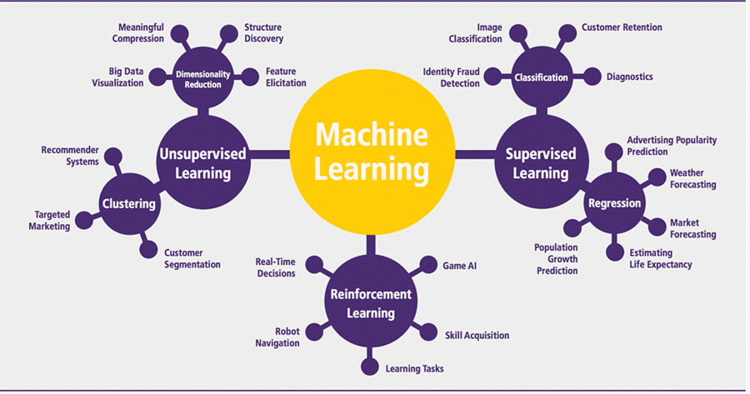

*Figure 1: Elements of Machine Learning (Kumar,2019)*

Machine learning (ML) works by enabling computer systems to learn from data, identify patterns, and make predictions or decisions without explicit programming (Mitchell, 2022). This is achieved through the development of algorithms that iteratively adjust their parameters based on the input data, improving their performance over time (Goodfellow et al., 2022)

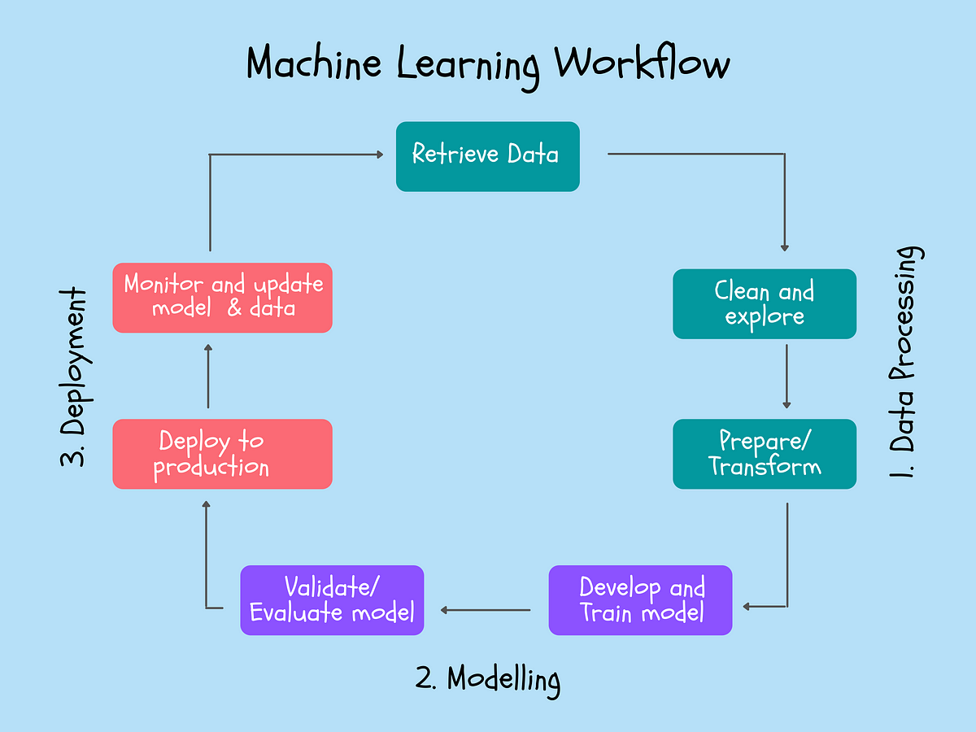

*Figure 2: A diagram of a machine learning process (Thevapalan, A., 2021)*

As shown in Figure 2, the process typically begins with collecting and preprocessing raw data, which may involve cleaning, transforming, and selecting relevant features. Next, a suitable ML algorithm is chosen and trained on the prepared data, where it learns to map input features to the desired output (e.g., classification labels or numerical values). This learning process often involves optimizing a cost function that measures the discrepancy between the model's predictions and the true values. Once trained, the model can be evaluated on unseen data to assess its generalization performance. Finally, the model can be deployed to make predictions on new data, potentially leading to automated decision-making or insights discovery.

The emergence of machine learning (ML) offers a promising avenue to overcome these limitations. Recent trends in optimization methods include a growing emphasis on data-driven approaches, real-time optimization algorithms, and simulation modelling (Rudloff et al., 2018; Wang et al., 2023). These approaches leverage big data and machine learning to enhance predictive modelling, decision support, and dynamic adaptation to changing conditions. For example, Chen et al. (2022) explored the use of reinforcement learning, a type of machine learning, for optimizing emergency vehicle dispatch and routing in real-time, taking into account factors like traffic congestion.

Machine learning algorithms can analyze vast amounts of data, including historical incident data, real-time traffic information, and other relevant factors, to identify patterns and relationships that can inform decision-making. This data-driven approach allows for more accurate predictions and more efficient resource allocation, potentially leading to significant reductions in response times. Real-time optimization algorithms, powered by machine learning, can continuously adapt dispatch and routing decisions based on the latest information, ensuring that the fastest and most efficient routes are chosen for each emergency response. Simulation modelling can also be used to test and refine different response strategies in a virtual environment before real-world implementation, further enhancing the effectiveness of ML-based optimization methods.

### Machine Learning Techniques for Optimizing Fire Brigade Response Time

Machine learning (ML) presents a promising avenue for optimizing fire brigade response times, a critical factor in mitigating fire damage and saving lives. ML techniques are being applied across various stages of emergency response, from prediction and decision-making to resource allocation and dispatching.

### Predictive Modelling for Enhanced Preparedness

Machine learning (ML) has shown significant potential in various aspects of fire brigade response optimization. Predictive modelling using ML algorithms has been employed to forecast fire risk, incident severity, resource needs, and optimal dispatch locations (Kedia et al., 2020). These models can analyse vast amounts of historical and real-time data to identify patterns and relationships that may not be apparent through traditional methods. For instance, Schmidt et al. (2023) employed a combination of bagged decision trees and Bayesian regularized neural networks to predict the severity of structure fire-related casualties. The model achieved a 92.5% accuracy in classifying casualty severity, demonstrating the potential of ML in predicting outcomes and informing resource allocation. The study also highlighted the importance of various factors in predicting fire-related casualties, including victim age, fire service response times, and the presence of working smoke detectors.

### Optimizing Dispatch and Routing Decisions

ML algorithms are also being utilized to optimize dispatch and routing decisions, a crucial aspect of minimizing response times. Dynamic routing algorithms that leverage ML can consider real-time traffic conditions, incident types, and resource availability (Rudloff et al., 2018). These algorithms adapt to changing circumstances, ensuring the fastest and most efficient routes are chosen for each response. For instance, Chen et al. (2022) proposed a reinforcement learning-based approach for optimizing emergency vehicle dispatch and routing, demonstrating its potential to reduce response times compared to traditional methods.

### Enhancing Decision-Making and Resource Allocation

ML is not only being applied to predict and optimize routes but also to enhance decision-making and resource allocation. Wang et al. (2020) explored the use of deep reinforcement learning to generate optimized strategies for emergency decision-making in traffic accidents. Their approach involved translating the decision-making process into a reinforcement learning problem, where an agent learns to make optimal decisions through trial and error. Lazuko et al. (2023) focused on reducing police response times by automating the dispatching system using supervised learning algorithms like Support Vector Machines (SVM) and logistic regression. Their system analyses voice-to-text conversions, extracts keywords, and dispatches the appropriate response unit based on pre-learned patterns. Lalitha et al. (2024) introduced DERO-RL, a real-time emergency dispatching system that utilizes reinforcement learning algorithms (Advantage Actor-Critic (A2C), Deep Q-Network (DQN), and Proximal Policy Optimization (PPO)) to optimize resource allocation and responder routing in complex emergency scenarios.

### Machine Learning: A Multifaceted Tool for Optimization

The diverse applications of ML in fire brigade response optimization highlight its potential as a multifaceted tool. By predicting fire risk, optimizing dispatch and routing, and enhancing decision-making and resource allocation, ML techniques can significantly improve the efficiency and effectiveness of emergency response. Further research and development in this area are expected to lead to even more sophisticated and impactful applications of ML in the future.

## Machine Learning Algorithms for Prediction

Machine learning (ML) algorithms offer a promising avenue for enhancing the prediction of fire brigade response times. Unlike traditional statistical methods, ML models can learn complex patterns and relationships within vast datasets, potentially leading to more accurate and nuanced predictions. Regression models are well-suited for predicting continuous outcomes like response times. They can incorporate various factors that influence response times, such as traffic conditions, time of day, incident type, and geographical location, to generate tailored predictions.

Goodman et al. (2021) demonstrated the potential of regression models in assessing the impact of Low Traffic Neighbourhoods (LTNs) on fire service emergency response times. Their study, although not explicitly specifying the type of regression used, highlights the capability of these models to handle complex scenarios involving interactions between multiple factors. The study's finding that LTNs did not negatively impact response times, even in the presence of physical barriers, underscores the potential for ML models to uncover non-intuitive relationships and inform evidence-based decision-making in fire brigade operations. However, it is important to note that the study's conclusions may not be generalizable to all contexts, as the impact of LTNs on response times may vary depending on specific local conditions and implementation strategies.

### Neural Networks

Multilayer Perceptrons (MLPs) are versatile neural networks capable of learning complex patterns in data. They can be used for both regression and classification tasks. In the context of fire response, MLPs could predict response times or classify incidents based on their severity. Recurrent Neural Networks (RNNs) (particularly LSTMs) excel at processing sequential data, making them ideal for analyzing time series of fire incidents. LSTMs (Long Short-Term Memory) are a type of RNN that can effectively capture long-term dependencies in the data, which is crucial for predicting future fire events and response time demands. While Convolutional Neural Networks (CNNs) are primarily used for image recognition, CNNs can also be applied to spatial data like maps. They could potentially identify spatial patterns in fire incident locations, aiding in resource allocation and route optimization.

## Case Studies and Real-World Applications

### Fire Susceptibility and Prevention

Kalantar et al. (2020) conducted a study to predict forest fire susceptibility in the Chaloos Rood watershed in Iran. The researchers aimed to develop a reliable model for identifying areas prone to forest fires, a critical aspect of effective fire management and prevention. They employed three machine learning (ML) models—Multivariate Adaptive Regression Splines (MARS), Support Vector Machine (SVM), and Boosted Regression Tree (BRT)—and investigated the impact of different resampling techniques (cross-validation and bootstrapping) on model performance. The study utilized 14 fire predictors derived from vegetation indices, climatic variables, environmental factors, and topographical features. The research found that all three ML models performed well in predicting forest fire susceptibility, with the BRT model achieving the highest accuracy (AUC = 0.91) using the optimism bootstrap resampling technique. The resampling process enhanced the prediction performance of all models. The study also identified the most influential factors contributing to forest fire susceptibility, including altitude, distance from rivers, rainfall, and distance from residential areas. These findings provide valuable insights for forest management and fire prevention agencies, enabling them to make informed decisions regarding resource allocation, fire prevention strategies, and land management practices. However, the study was limited to a specific watershed in Iran and relied on a limited number of fire inventory points. Future research could explore the use of other ML algorithms, incorporate additional data sources like real-time weather data and satellite imagery, and validate the models in different regions.

Furthermore, machine learning has been applied to fire detection and prediction this is evident as Alkhatib et al. (2023) reviewed various ML algorithms used for fire detection, such as artificial neural networks (ANN), convolutional neural networks (CNN), and decision tree (DT) methods, utilizing data from meteorological information, camera data, and wireless sensor networks (WSN). In the realm of fire prediction, the review discusses the application of ML algorithms like random forest (RF), multilayer perceptron (MLP), logistic regression, and Bayesian networks (BNN) to analyze diverse datasets, including satellite-based fire data, GIS data, and meteorological data. These models have shown promising results in predicting fire ignition probability, fire scale, and the spatial evolution of forest fires.

### Emergency Response Time Optimization

Ottah and Caramancion (2023) investigated the impact of geographic socioeconomic conditions on Emergency Medical Services (EMS) response times in New York City, focusing on the potential influence of neighbourhood poverty levels. The research aimed to examine the relationship between neighbourhood poverty and EMS response times, assess variations in response times across neighbourhoods, determine the association between these variations and poverty levels, and evaluate the consistency of this relationship across geographic units. The study hypothesized that lower socioeconomic status (SES) regions typically experience longer response times compared to higher SES areas. The study anticipated findings that could confirm or deny this hypothesis, identify variations in response times across neighbourhoods, and determine the association between these variations and poverty levels. However, the research was limited to a single EMS unit within the New York City Fire Department Bureau of EMS and relied on secondary datasets, which may have limitations in accuracy and completeness. Future research directions include expanding the study to multiple EMS units, exploring the impact of implicit bias among dispatchers and ambulance personnel, and investigating interventions to reduce response time disparities in low-income areas. This research is significant as it can inform policymakers, EMS providers, and community stakeholders about potential disparities in response times, guiding efforts to improve the quality and efficiency of emergency services, ultimately benefiting the health and well-being of all residents, particularly those in underserved communities.

In the context of ambulance response, Arcolezi et al. (2021) investigated the application of machine learning (ML) to predict ambulance response times (ARTs) while preserving the privacy of emergency location data. The study focused on the Departmental Fire and Rescue Service of Doubs (SDIS 25) in France, which, like many Emergency Medical Services (EMS) worldwide, is experiencing an increase in interventions that could potentially impact ARTs. The researcher recognized the importance of location data in predicting ARTs but also acknowledged the sensitivity of this information due to privacy concerns. The study also identified the most influential variables for ART prediction, including temporal features (hour, day), weather data, traffic data, and the distance between the emergency scene and the dispatch centre. The research had two main objectives: to develop ML models for accurate ART prediction and to protect the privacy of emergency location data using geo-indistinguishability (GI), a privacy model based on differential privacy. The study found that GI could effectively sanitize location data without significantly impacting the accuracy of ART predictions. Additionally, the research identified key variables influencing ART, including temporal features, weather, traffic, and distance to the dispatch centre. However, the study had limitations, such as its focus on a single EMS provider in France and its reliance on retrospective data. The researchers proposed expanding the analysis to other aspects of EMS operations, incorporating additional variables, and conducting field studies to assess the real-world impact of their privacy-preserving ART prediction system.

### Fire Brigade Operations and Resource Allocation

Elias Mallouhy et al. (2022) conducted a study on predicting the number of firefighter interventions based on the type of mission. The research utilized data from the Departmental Fire and Rescue Service of Doubs (SDIS 25) in France, categorizing interventions into 14 distinct types. The primary objective was to develop machine learning models capable of predicting the number of firefighter interventions for each category, aiming to improve emergency response efficiency by aligning resource allocation with anticipated demand. The study successfully created 14 sub-datasets, each corresponding to a specific type of intervention. The XGBoost and LightGBM algorithms were employed to predict the number of interventions for each category. The results showed promising accuracy, particularly for categories with larger datasets and clear seasonal patterns, such as fires. However, the study acknowledged limitations in prediction accuracy due to the limited use of explanatory variables, relying only on time and date features. Additionally, the potential redundancy in categorizing certain interventions, such as a fire in a building falling under multiple categories, was noted. Despite these limitations, the research provides a valuable framework for predicting the demand for different types of fire brigade interventions. This information can be used to optimize resource allocation, improve operational planning, and enhance the efficiency and effectiveness of emergency response services. Future work could focus on incorporating additional explanatory variables, such as weather conditions, location-specific factors, and resource availability, to improve the accuracy of the models. Additionally, exploring feature selection and breakpoint detection techniques could further refine the predictions.

Cerna et al. (2020) conducted a case study with the Departmental Fire and Rescue Doubs (SDIS25) in France to develop a methodology for calculating and predicting operational breakdowns in fire brigades. The research aimed to establish indicators to identify failures due to resource limitations and forecast disruptions to inform resource allocation strategies. The study successfully developed a breakdown calculation process and a predictive model using the XGBoost machine learning technique. The model achieved promising results in predicting public service breakdowns, with a root mean squared error of 2.5602 and a mean absolute error of 2.0240. However, the study was limited to a single fire department and a relatively small dataset. The researcher suggests future research to explore the creation of artificial data, utilize time series techniques for forecasting, and develop methodologies to recommend resource allocation strategies. They also propose adapting the breakdown calculation algorithm for other fire departments. This research is crucial for fire departments as it provides a tool to identify and predict operational breakdowns, enabling them to proactively manage resources and improve operational resilience, leading to increased efficiency, reduced response times, and enhanced public safety.

Shaikh and Gajjar (2023) explored the application of machine learning (ML) techniques for real-time ambulance detection using drones. The study aimed to address the issue of delayed ambulance arrivals due to traffic congestion, which can have severe consequences for patients in need of emergency medical care. The researchers employed various versions of the You Only Look Once (YOLO) object detection algorithm, a ML technique for real-time object detection in images and videos. The study involved creating a diverse dataset of ambulance images, training YOLOv5 and YOLOv8 models on this dataset, and deploying the trained models on two edge AI hardware platforms: Intel's UP Squared board and Nvidia Jetson Nano. The models were evaluated using a dedicated test dataset and real-time drone videos captured in various environments and traffic conditions. The results demonstrated the effectiveness of the approach, with YOLOv8 outperforming YOLOv5 in terms of accuracy, achieving a mean Average Precision (mAP50-90) of 0.979. The Intel UP Squared board also showed better performance than the Nvidia Jetson Nano in terms of speed and processing capability. This research highlights the potential of using drones and machine learning for real-time ambulance detection, which can significantly improve emergency response systems and traffic management during emergencies. However, the study was limited to a specific dataset and environment, and the performance of the models may vary in different scenarios. The power consumption of the edge AI devices was also a consideration for real-world deployment. Shaikh and Gajjar (2023) suggest exploring the use of more advanced ML models and incorporating additional features, such as siren detection, to improve the accuracy and robustness of the system. They also recommend investigating the potential of integrating the system with traffic management systems to prioritize ambulance routes and improve traffic flow during emergencies

These studies collectively demonstrate the potential of machine learning in optimizing various aspects of fire brigade response, from predicting fire incidents and their severity to optimizing dispatch, routing, and resource allocation. By leveraging the power of data-driven approaches and real-time optimization, machine learning can significantly enhance the efficiency and effectiveness of fire brigade operations, ultimately leading to improved public safety and reduced fire-related casualties and property damage.

The table below shows the summary of different research papers that carried out research based on fire prevention, emergency response time and fire detection.

|  |  |  |  |  |  |  |  |
| --- | --- | --- | --- | --- | --- | --- | --- |
| Paper Title | Year Published | Authors | Properties Predicted | Techniques Used | Measurement Metrics | Limitations | Result |
| Predicting EMS Response Time using Geographic Zones’ Socio-Economic Indicators | 2023 | Alice Nneka Ottah, Kevin Matthe Caramancion | EMS response time | Geographic weighted regression (GWR), Surveys, Regression models, Content analysis | Response time, Socioeconomic status, Poverty level | Only one EMS unit in New York City will be surveyed |  |
| The Impact of 2020 Low Traffic Neighbourhoods on Fire Service Emergency Response Times, in London, UK | 2021 | Anna Goodman, Anthony A. Laverty, Asa Thomas, Rachel Aldred | Fire service emergency response times | Linear regression analysis | Response time | Only focused on the London Fire Brigade | LTNs did not adversely affect emergency response times |
| Predicting Fire Brigades Operational Breakdowns: A Real Case Study | 2020 | Cerna, S., Guyeux, C., Royer, G., Chevallier, C., & Plumerel, G. | Public service breakdowns (a type of operational disruption) | XGBoost, MLP, Bayesian Ridge Regression, SVM, Random Forest | RMSE, MAE | Small dataset size, limited to public service breakdowns | XGBoost achieved the best average performance with RMSE of 2.5602 and MAE of 2.0240. |
| Preserving Geo-Indistinguishability of the Emergency Scene to Predict Ambulance Response Time | 2021 | Arcolezi, H.H., Cerna, S., Guyeux, C., & Couchot, J.F. | Ambulance Response Time (ART) | XGBoost, LGBM, MLP, LASSO | RMSE, MAE, MAPE, R^2 | Limited to one EMS in France, potential human error in recording arrival time | Sanitization of location data with geo-indistinguishability had no considerable impact on predicting ARTs. LGBM and XGBoost achieved the best performance. |
| Analysis of Fire Response Time with Lean Service Method in City of Medan Fire and Prevention Service | 2020 | Meliala, G.H.I., Matondang, N., & Hidayati, J. | Fire response time | Lean Service, Value Stream Mapping, Fishbone Diagram | Process cycle efficiency | Focuses on internal factors only, limited to one fire department | Process cycle efficiency increased from 72.64% to 81.08%, indicating a reduction in waste and improvement in response time. |
| Industrial Fire Brigade Emergency Response Time Parameters for Oil & Gas Facility | 2023 | Bujang, Z. et al. | Emergency Response Time | Semi-structured Interviews | Response time | Limited to expert opinion | Identified key parameters to reduce emergency response time. |
| Predicting fire brigades’ operations based on their type of interventions | 2022 | Elias Mallouhy, R. et al. | Number of firefighter deployments | XGBoost and LightGBM | Mean absolute error (MAE) and root mean square error (RMSE) | Limited explanatory variables | Promising accuracy in predicting firefighter deployments. |
| Location Optimization of Urban Fire Stations Considering the Backup Coverage | 2023 | Tao, L. et al. | Optimal location of fire stations | Backup coverage model, SAVEE model, PIPS | General coverage rate, backup coverage rate, risk coverage rate | Ignores service in low fire risk areas | Backup coverage model enhances safety in high fire risk areas. |
| A Brief Review of Machine Learning Algorithms in Forest Fires Science | 2023 | Alkhatib, R. et al. | Fire detection, fire prediction, fire mapping | Various machine learning and deep learning techniques | Accuracy, precision, recall, F1 score, AUC | Data scarcity, computational power, accuracy evaluation | Deep learning shows promise in forest fire applications. |
| An Expert System to Reduce Emergency Response Time Using a Machine Learning Technique | 2021 | Rana Mohtasham, M. Junaid, Mariam Ijaz, Rana Saima Aftab | Case nature, location, contact number | Data mining, data parsing, data segmentation, deep learning | Accuracy (91.17%), response time | Limited to police-related emergencies, requires further testing in real-world scenarios | Minimized emergency response time |
| Performance Evaluation of Ambulance Detection and Classification Using Machine Learning Through a Drone on Edge AI Devices | 2023 | Aayrin M. Shaikh, Ruchi Gajjar | Ambulance detection and classification | YOLOv5, YOLOv8 object detection algorithms | Mean Average Precision (mAP50-90): 0.723 (YOLOv5), 0.979 (YOLOv8) | Limited to Indian ambulance designs, real-world performance may vary | Real-time ambulance detection using drones |
| Machine Learning Based Risk Analysis and Predictive Modeling of Structure Fire related Casualties | 2023 | Andres Schmidt, Eric Gemmil, Russ Hoskins | Severity of fire-related injuries, spatial risk classification | Bagged decision tree classifiers, random forest algorithm, Bayesian regularized neural network ensemble classifier | Accuracy: 85.3% (random forest), 92.5% (neural network), 87.6% (spatial model) | Limited to Oregon, data constraints on fire intensity and building materials | Identified key predictors of fire-related casualties, developed spatial risk model |

Table 1: Research papers summary

## Gaps in Literature

Many studies focus on specific emergency scenarios or regions, making it difficult to generalize findings to other contexts. For example, Alkhatib et al. (2023) primarily focuses on forest fire detection and prediction, while Lazuko et al. (2023) concentrate on police response scenarios. This study will address this gap by examining a broader range of emergency response scenarios and exploring the potential for generalizable solutions. Existing research often overlooks the dynamic nature of emergencies, where situations can change rapidly. Wang et al. (2020) acknowledge the need for real-time adaptability in their study on emergency decision-making but do not fully address it. This study will focus on developing machine learning models that can adapt to changing circumstances, ensuring that emergency response strategies remain effective throughout the duration of an incident.

While some studies utilize multiple data sources, there is still a need for more comprehensive integration of diverse data types, such as social media data, sensor data, and historical incident records. Shaikh et al. (2023) and Arcolezi et al. (2021) incorporate various data sources in their respective studies on ambulance detection and response time prediction. The ethical implications of using machine learning in emergency response, such as potential biases in algorithms and the impact on vulnerable populations, are not always thoroughly addressed. Arcolezi et al. (2021) touch upon privacy concerns in their work, but a more in-depth exploration of ethical considerations is needed. This study will prioritize ethical considerations throughout the research process, ensuring fairness, transparency, and accountability in the development and deployment of machine learning models.

There is a lack of studies that rigorously evaluate the performance of machine learning models in real-world emergency response scenarios. While Shaikh et al. (2023) test their ambulance detection model in real-time using drones, further research is needed to assess the effectiveness of various machine learning techniques in diverse emergency situations. This study will contribute by conducting comprehensive evaluations, bridging the gap between research and practical implementation.

# METHODOLOGY

## ****Research Design****

This project will adopt a primarily quantitative research design. The focus is on using statistical analysis and machine learning models to identify patterns and relationships within the London Fire Brigade (LFB) data, aiming to predict response times and ultimately optimize resource allocation. However, a mixed-methods approach could be incorporated to supplement quantitative findings.

## Dataset

The primary data utilized in this research originates from a publicly accessible incident dataset available on the London Fire Brigade's (LFB) website. This comprehensive dataset encompasses historical records of fire incidents, comprising 713,368 rows and 39 columns, and spans from January 2018 to April 2024. Typically provided in an Excel (.xlsx) format, this dataset offers valuable insights into various aspects of fire incidents and response times. Table 2 below shows the metadata of the dataset

|  |  |  |
| --- | --- | --- |
| Column Name | Data Type | Description |
| IncidentNumber | Object | A unique identifier for each incident. |
| DateOfCall | Datetime64[ns] | The date and time the call was received. |
| CalYear | Int64 | The calendar year of the incident. |
| TimeOfCall | Object | The time of the call in HH:MM:SS format. |
| HourOfCall | Int64 | The hour of the call (0-23). |
| IncidentGroup | Object | The general category of the incident (e.g., Fire, Special Service). |
| StopCodeDescription | Object | A more detailed description of the incident type. |
| SpecialServiceType | Object | The type of special service provided (if applicable). |
| PropertyCategory | Object | The general category of the property involved (e.g., Dwelling, Non-Residential). |
| PropertyType | Object | The specific type of property involved (e.g., Bungalow, Shop). |
| AddressQualifier | Object | Additional information about the address (e.g., Flat, Rear). |
| Postcode_full | Object | The full postcode of the incident location. |
| Postcode_district | Object | The district part of the postcode. |
| UPRN | Int64 | Unique Property Reference Number, a unique identifier for each addressable property in the UK. |
| USRN | Int64 | Unique Street Reference Number, a unique identifier for each street in the UK. |
| IncGeo_BoroughCode | Object | The code of the borough where the incident occurred. |
| IncGeo_BoroughName | Object | The name of the borough where the incident occurred. |
| ProperCase | Object |  |
| IncGeo_WardCode | Object | The code of the ward where the incident occurred. |
| IncGeo_WardName | Object | The name of the ward where the incident occurred. |
| IncGeo_WardNameNew | Object |  |
| Easting_m | Float64 | The easting coordinate in meters (British National Grid). |
| Northing_m | Float64 | The northing coordinate in meters (British National Grid). |
| Easting_rounded | Int64 | The rounded easting coordinate. |
| Northing_rounded | Int64 | The rounded northing coordinate. |
| Latitude | Float64 | The latitude coordinate of the incident location. |
| Longitude | Float64 | The longitude coordinate of the incident location. |
| FRS | Object | The Fire and Rescue Service responsible for the incident. |
| IncidentStationGround | Object | The station that responded to the incident. |
| FirstPumpArriving_AttendanceTime | Float64 | The attendance time of the first pump arriving at the scene. |
| FirstPumpArriving_DeployedFromStation | Object | The station from which the first pump was deployed. |
| SecondPumpArriving_AttendanceTime | Float64 | The attendance time of the second pump arriving at the scene. |
| SecondPumpArriving_DeployedFromStation | Object | The station from which the second pump was deployed. |
| NumStationsWithPumpsAttending | Float64 | The number of stations with pumps attending the incident. |
| NumPumpsAttending | Float64 | The total number of pumps attending the incident. |
| PumpCount | Int64 | The count of pumps involved in the incident. |
| PumpMinutesRounded | Int64 | The total time spent by pumps at the incident, rounded to the nearest minute. |
| Notional Cost (£) | Int64 | The estimated cost of the incident. |
| NumCalls | Float64 | The number of calls related to the incident. |

*Table 2. LFB Dataset*

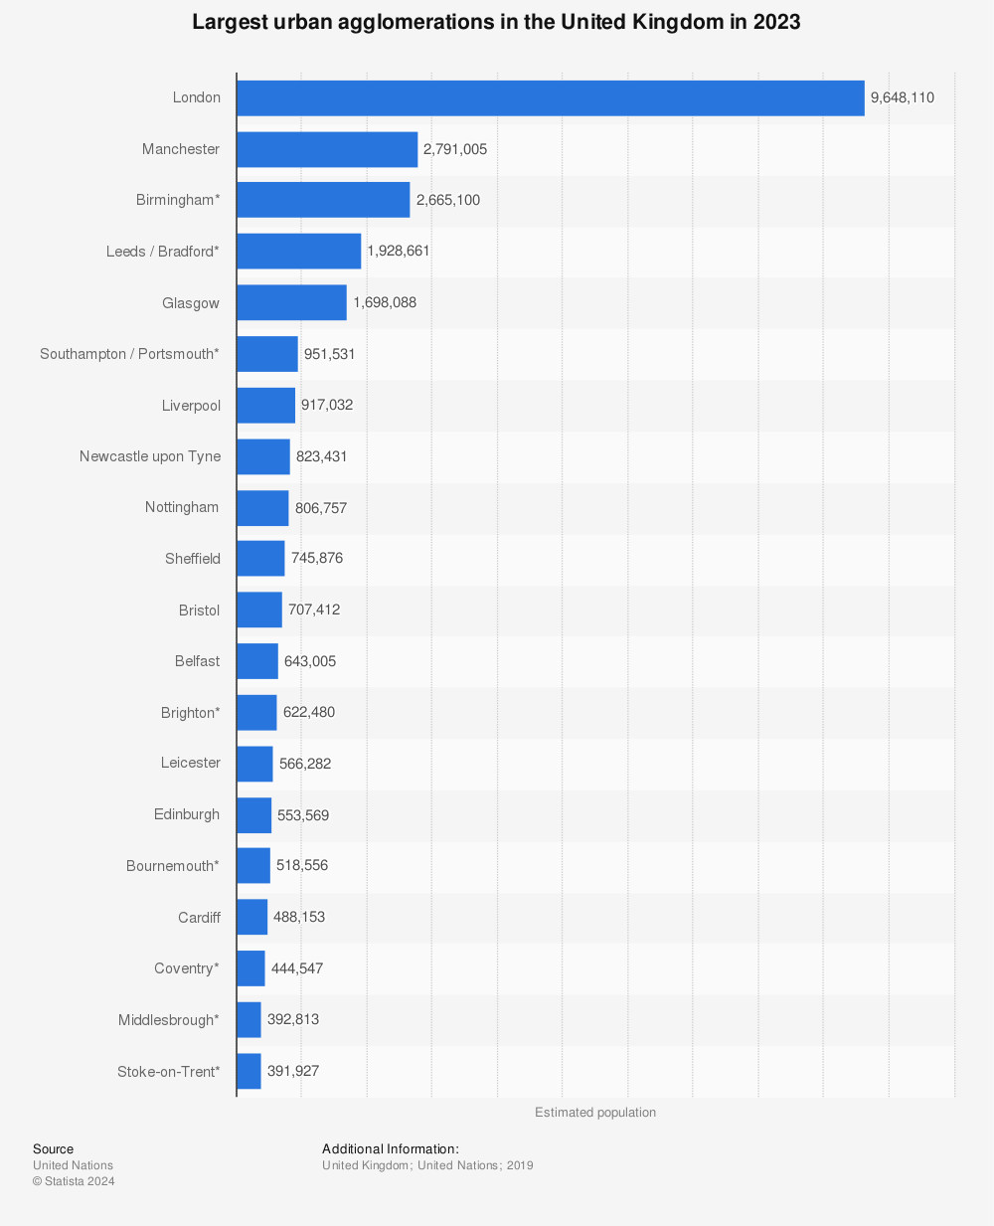

*Figure 3: population size of London (Statista, 2024)*

Having the highest population in the United kingdom signifies the likelihood of recording the highest number of incidents yearly. The London Fire Brigade dataset is the most suitable for this study due to its comprehensive nature, encompassing a wide array of factors relevant to emergency response times. These factors include temporal features (e.g., hour, day) and precise location coordinates. This dataset's richness allows for a nuanced analysis of the interplay between various factors and their impact on response times, enabling the development of a more accurate and effective predictive model. Additionally, the dataset's size, spanning 7 years and encompassing a substantial number of dispatches, ensures the model's robustness and generalizability. Furthermore, the inclusion of diverse emergency scenarios within the dataset allows for the exploration of tailored response strategies for different types of incidents, enhancing the overall effectiveness of the emergency response system.

## Data Processing

The initial data processing involved a comprehensive exploration of the LFB dataset. This began with understanding the dataset's structure using df.info(), which revealed column names, data types, and the presence of missing values. Further insight was gained through df.describe(), which provided descriptive statistics for numerical columns, highlighting the data's distribution and potential outliers. The number of missing values per column was also calculated using df.isnull().sum(). To address potential outliers in the numerical columns, an Interquartile Range (IQR) based capping method was employed.

This function, cap_outliers_iqr(df, columns), systematically identified and capped outliers within the specified numerical columns using a standard threshold of 1.5 times the IQR. The 25th and 75th percentiles were calculated to define the IQR, and any values falling outside the calculated lower and upper bounds were replaced with the respective bounds. The effectiveness of the outlier capping process was then verified by displaying the first 5 rows of the modified DataFrame (capped_df) using print(capped_df.head()). This provided a visual confirmation that outliers had been adjusted as intended, preparing the data for further analysis and modelling. The impact of outlier capping was visually assessed by generating boxplots for each numerical column before and after the process using the plot_boxplots function. This allowed for a clear visual comparison of the data distribution changes, confirming the effectiveness of the outlier handling procedure and ensuring the data's readiness for further analysis.

## Feature Scaling

MinMax scaling is used to normalize the features. MinMax scaling transforms the features to a range between 0 and 1. This is done by subtracting the minimum value of the feature and then dividing by the range (maximum value - minimum value). This scaling technique is beneficial for algorithms and neural networks, as they are sensitive to the scale of the input features. By scaling the features, we ensure that all features contribute equally to the model's learning process.

## Machine Learning Models

This study leverages a comprehensive suite of machine learning (ML) models to predict fire brigade response times, capitalizing on their distinct characteristics and adapting them to the nuances of the dataset.

**Linear Regression**: Linear regression is a fundamental statistical model that assumes a linear relationship between the predictor variables (e.g., time of day, incident type, distance) and the response variable (response time). Its simplicity makes it easily interpretable, providing clear insights into the impact of each predictor on the outcome (James et al., 2021). However, its linear assumption may oversimplify the complex, often non-linear relationships inherent in real-world phenomena like fire brigade response times. Despite this limitation, linear regression serves as a valuable baseline model, enabling us to assess the incremental value offered by more sophisticated algorithms.

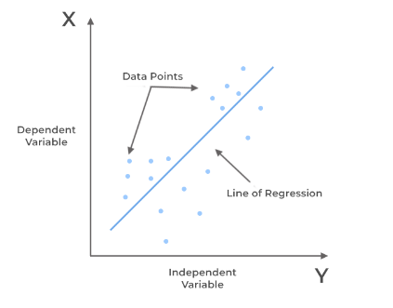

*Figure 4: Best line of fit for a linear regression model (Kanade, 2022)*

**Random Forest Regression**: Random forest regression is an ensemble learning method that harnesses the power of multiple decision trees as shown in figure 5. Each tree is trained on a random subset of the data and features, resulting in a diverse collection of predictors. By aggregating the predictions of these individual trees, random forests mitigate the risk of overfitting and can capture non-linear relationships between predictors and the response variable (Biau & Scornet, 2016). This robustness to noise and outliers makes it a compelling choice for modelling the intricate interplay of factors that influence response times.

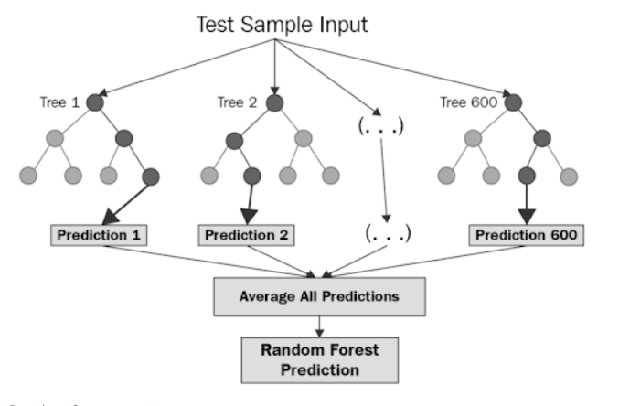

Figure 5: Random Forest Decision tree (Chakure, 2023)

**Gradient boosting** is another ensemble technique that sequentially trains a series of weak prediction models, with each subsequent model focusing on correcting the errors of its predecessors evident from Figure 6. This iterative process progressively improves the model's accuracy by learning from its mistakes (Chen & Guestrin, 2016). The adaptability of gradient boosting allows it to effectively capture complex patterns and interactions in the data, making it well-suited for predicting response times that may be influenced by numerous interconnected factors.

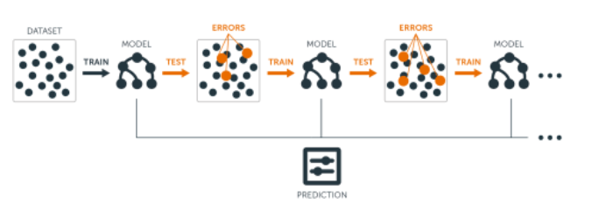

Figure 6: Gradient Boost sequential assemble approach (UC Business Analytics R Programming Guide, n.d.)

**XGBoost** is a highly optimized implementation of gradient boosting, renowned for its exceptional speed, scalability, and regularization techniques that further enhance its resistance to overfitting (Chen & Guestrin, 2016). Its impressive performance has propelled it to prominence in various machine learning competitions and real-world applications, establishing it as a leading candidate for this research. By incorporating features like parallel processing and tree pruning, XGBoost efficiently handles large datasets and delivers accurate predictions in a computationally efficient manner.

**MLP (Multilayer Perceptron**): MLPs, a type of artificial neural network, are composed of interconnected nodes (neurons) organized in three layers: input, hidden, and output layer(s) as shown in Figure 8. They are capable of learning complex, non-linear relationships within data through a process of adjusting connection weights based on the input data and desired output (Gardner & Dorling, 2019). This flexibility allows MLPs to capture intricate patterns that may not be easily discerned by simpler models. However, they require careful tuning of hyperparameters to avoid overfitting and may lack the interpretability offered by models like linear regression. Equation 1 is used to describe the MLP network.

where *m* indicates the number of hidden layers, *b* is the bias (threshold) of the output layer, and $w_{j}$ illustrates the connection weights of the output layer to *j-th* neuron in the hidden layer. $φ_{j}$ indicates the output of the *j* hidden layer which is computed through conversion of the linear combination via a nonlinear activation function, commonly the Tansig function.

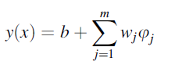

Equation 1

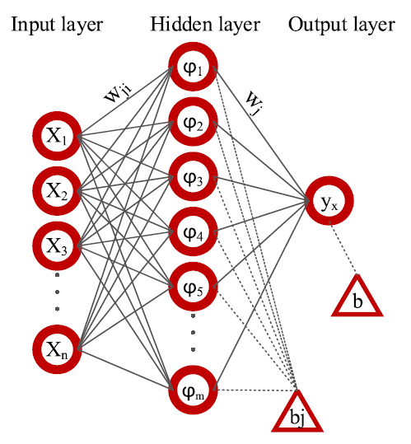

Figure 9: Schematic of a multilayer perceptron neural network (Kohzadvand, Kouhi, Ghasemi, & Shafiei, 2024)

**LSTM (Long Short-Term Memory):** LSTMs are a specialized form of recurrent neural networks designed to handle sequential data, such as time series data like fire brigade response times (Hochreiter & Schmidhuber, 1997). They are equipped with a unique memory mechanism that enables them to capture long-term dependencies within the data, making them particularly adept at modeling scenarios where past events can significantly influence future outcomes. This makes LSTMs a promising candidate for predicting response times, which are likely influenced by temporal factors like traffic patterns and historical incident data.

For training and evaluation, the dataset was divided into an 80% training set and a 20% testing set, enabling assessment of model performance on unseen data and preventing overfitting. Each model was trained on the training set using default hyperparameters and subsequently used to predict response times on the test set.

## Model Evaluation metrics

To assess the efficacy of each model, several evaluation metrics were employed: Mean Squared Error (MSE), Root Mean Squared Error (RMSE), Mean Absolute Error (MAE), and R-squared (R²). These metrics provided a comprehensive view of prediction accuracy, error magnitudes, and the proportion of explained variance in the response times.

**Mean Squared Error (MSE):** This calculates the average squared difference between predicted and actual values as shown in equation 2. MSE is sensitive to outliers because squares magnify large errors. The lower the MSE the better the fit.

$$MSE = \frac{1}{n}\sum_{i=1}^{n}{{(y_{i}-\hat{y_{i}})}^{2}}$$

Equation 2: Mean squared error

Where:

$$y_{i} = actual value$$

$$\hat{y_{i}} = predicted value$$

$$n = number of observations$$

**Root Mean Squared Error (RMSE):** From equation 3 the RSME is the square root of MSE, making the interpretation easier. The units are the same as the target variable, aiding the understanding of error magnitude. Similar to MSE, lower RMSE signifies a better model.

$$RSME =\sqrt{\frac{1}{n}\sum_{i=1}^{n}{{(y_{i}-\hat{y_{i}})}^{2}}}$$

Equation 3: Root Mean squared error

**Mean Absolute Error (MAE):** This calculates the average of the absolute differences between predicted and actual values. It is less sensitive to outliers than MSE and RMSE. MAE is easier to interpret as it represents the average prediction error. Mathematically MAE is represented by equation 4 below

$$MAE = \frac{1}{n}\sum_{i=1}^{n}{\left|y_{i}-\hat{y_{i}}\right|}$$

Equation 4: Mean Absolute Error

**R-squared (R²):** The R-squared value represents the proportion of variance in the target variable explained by the model. It ranges from 0 (no explanation) to 1 (perfect fit). Although the higher the R-squared the better, a high R² doesn't guarantee a good model because overfitting can inflate the R-squared value. Equation 5 is the mathematical representation of the R-squared value.

$$R^{2}= 1-\frac{\sum_{i=1}^{n}{{(y_{i}-\hat{y_{i}})}^{2}}}{\sum_{i=1}^{n}{{(y_{i}-\overline{y})}^{2}}}$$

$$\overline{y} = mean of actual values$$

Equation 5: R-squared

## Model Validation and Hyperparameter Tuning

Following the initial evaluation with default hyperparameters, **RandomizedSearchCV** was utilized for hyperparameter tuning. This approach randomly samples hyperparameter combinations from a defined search space, offering a more computationally efficient alternative to GridSearchCV, which exhaustively evaluates all possible combinations. Given the computational limitations of the available hardware and the potentially large number of hyperparameter combinations, RandomizedSearchCV was deemed more suitable to explore a wider range of configurations within a reasonable timeframe.

The choice of RandomizedSearchCV allowed for efficient exploration of hyperparameter space, mitigating the risk of overfitting while maintaining computational feasibility. The results obtained through cross-validation and hyperparameter tuning provide a robust assessment of each model's predictive power and enable informed selection of the most optimal configuration for predicting fire brigade response times.

# RESULTS

This section is divided into 4 sub-sections, discussing the results of Exploratory data analysis (EDA), evaluation metrics obtained from the models and also results obtained from hyperparameter tuning using Randomized Search Cross-validation

## Exploratory Data Analysis (EDA)

Exploratory data analysis is mainly performed on raw datasets to extract information as it is from the dataset. Figure 4 shows the distribution of fire incidents across different property categories. Each bar represents a category (e.g., "Dwelling," "Outdoor," etc.), and the height of the bar indicates the total number of incidents that occurred within that category. Figure 4 demonstrates a notable discrepancy in the frequency of fire events among different property categories in the dataset. Residential fires provide the greatest risk, as indicated by the high frequency of events in the "Dwelling" category. Following that on the list are "Non-Residential" properties, which include commercial and industrial buildings. This emphasises the significance of fire safety precautions in both home and business environments. It is worth mentioning that fires occurring in outdoor areas and road vehicles also make a substantial contribution to the total number of incidents. This highlights the importance of taking care in open spaces and maintaining vehicles properly. Conversely, occurrences involving "Rail Vehicle," "Aircraft," or "Boat" are somewhat less frequent, although they still require readiness and specialised response procedures. This data highlights the importance of implementing fire prevention techniques and allocating resources depending on the individual hazards of each property category.

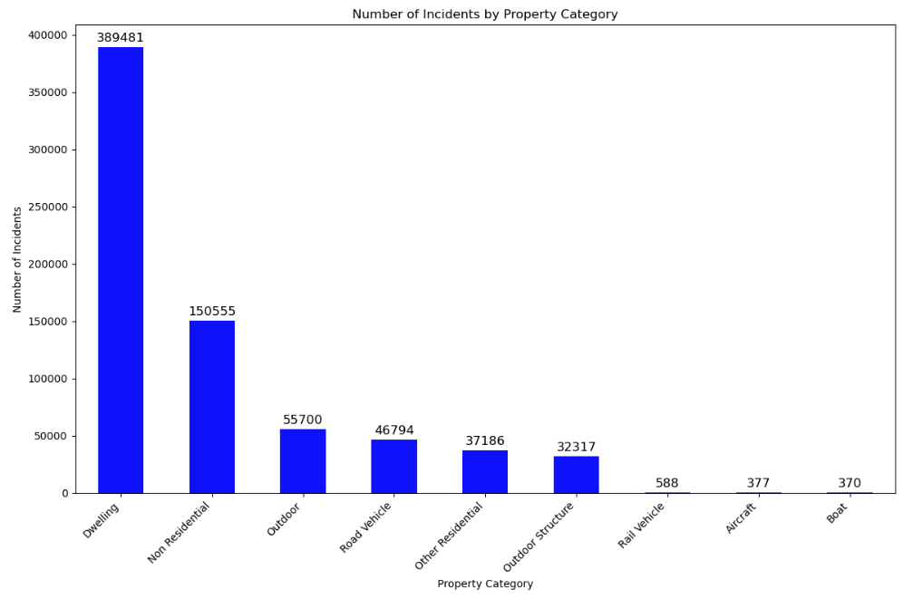

**Figure 4: number of incidents by type of property**

Figure 5 illustrates the average response time of the first pump arriving at fire incidents across different property categories. Response times vary significantly, ranging from approximately 288 seconds for "Other Residential" properties to 349 seconds for "Outdoor" fires. Notably, "Boat" and "Outdoor" fires exhibit the longest average response times, suggesting potential challenges in accessing and addressing these types of incidents promptly. On the other hand, "Other Residential," "Rail Vehicle," and "Non-Residential" properties show relatively shorter response times, indicating a more efficient response in these categories. "Dwelling" and "Aircraft" fires fall in the middle range, demonstrating moderate response times compared to the extremes. This information can be crucial for fire departments to optimize their resource allocation, response strategies, and training programs to improve overall response times and potentially save lives and property

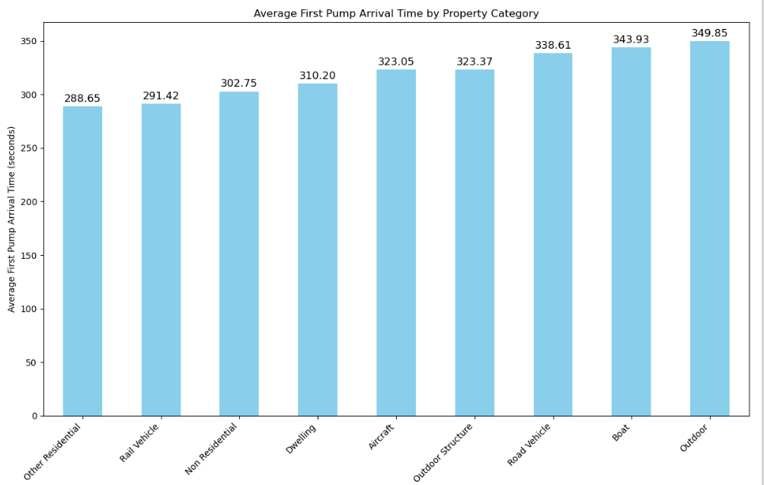

Figure 5: average response time by property type

Figure 6 shows the fire incident average first pump arrival time by call hour. Response times vary throughout the day, according to data. Response times are longest between midnight and 6 a.m., peaking at 7 a.m. Response times drop in the late morning and early afternoon, then peak at 8 p.m. As the night progresses, response times gradually decrease, reaching their shortest duration around 3 a.m. This shows that peak-hour fire events, especially in the morning and evening, may be responded to more slowly than off-peak incidents. This association between time of day and response times can help fire departments optimise resource allocation and staff scheduling. They can strategically place resources to minimise response time and improve efficiency by predicting demand peaks.

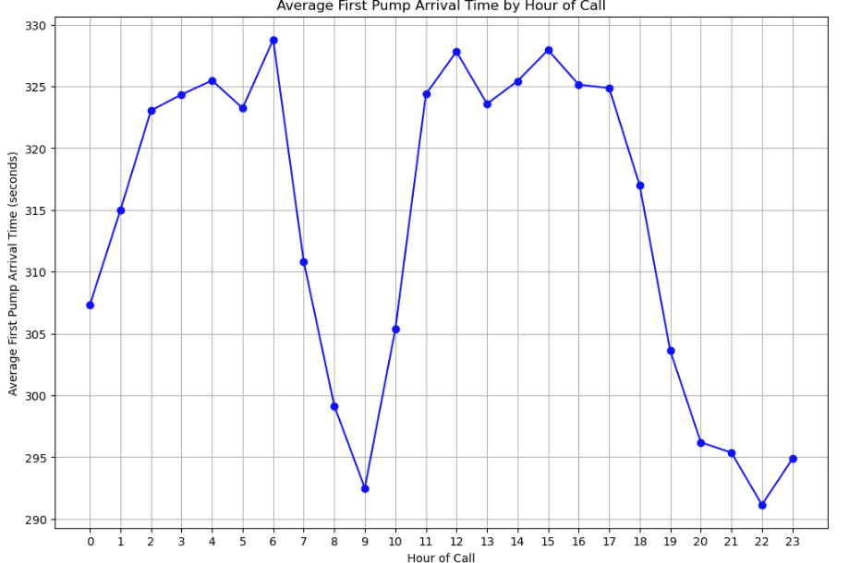

Figure 6: average response time by call hour

The stacked bar chart in figure 7 reveals distinct patterns in fire incident frequency and type throughout the day. Incidents peak in the late afternoon and early evening, attributed to increased activity and potential fire hazards. Dwelling fires remain the most frequent, though their proportion slightly decreases during peak hours as other incident types, like outdoor and road vehicle fires, become relatively more common. Conversely, incidents in non-residential properties, outdoor structures, and rail vehicles remain relatively stable.

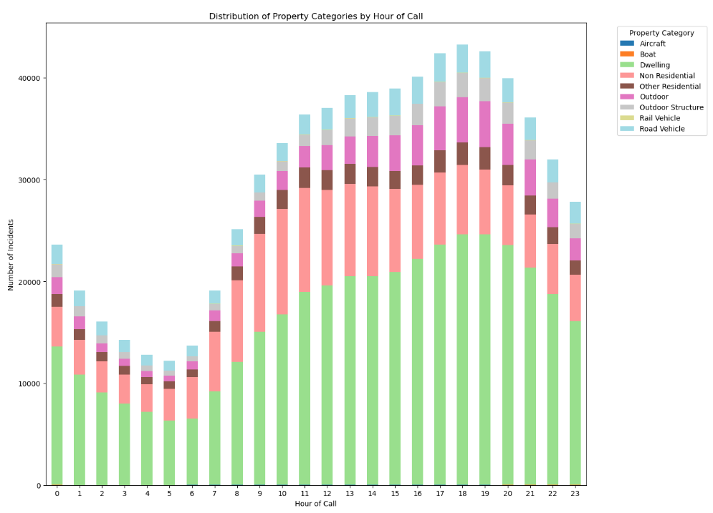

Figure 7: fire incident frequency and type throughout the day

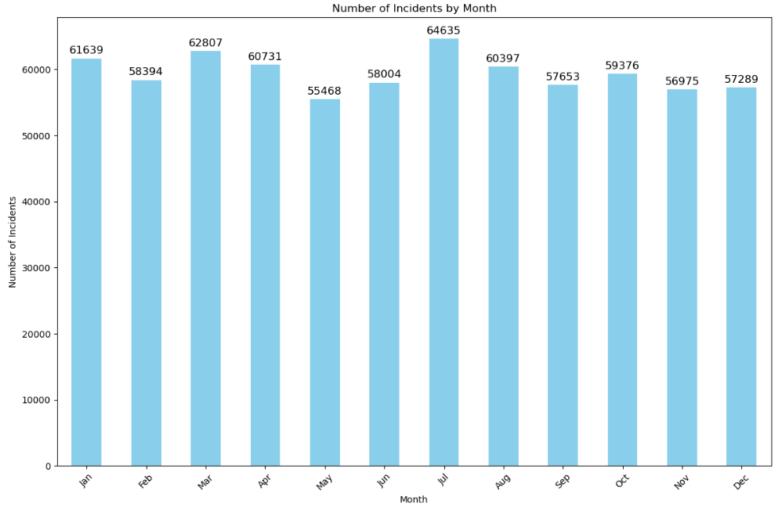

Figure 8: fire incidents across months of the year

Figure 8 illustrates the distribution of fire incidents across months of the year, revealing a cyclical pattern. The highest number of incidents occur in February, March, April, and July, while the lowest occur in May and June. This suggests a potential correlation between fire frequency and seasonal factors, possibly influenced by weather conditions, human behaviour, or holiday periods. The consistent frequency throughout the latter half of the year implies that while there are fluctuations, fire incidents remain a persistent concern regardless of the season.

As shown in Figure 9, the average amount of time it took for the fire brigade emergency services to respond to a variety of different types of incidents is depicted. False alarm, fire, and special service are the three distinct types that can be distinguished from one another. With a mean reaction time of around 325 seconds, the "Fire" occurrences have the highest average reaction time that is measured. The "Special Service" category comes in next, with an average response time of around 323 seconds. This category is the next available option. Incidents that are categorised as "False Alarms" have the quickest average reaction time, which is roughly 304 seconds. The differences in mean response times between the three categories are, for the most part, minor. This suggests that the nature of the incident does not have a substantial impact on the promptness with which the fire brigade arrives at the spot. On the other hand, the somewhat longer response time for "Fire" incidents could be attributed to the fact that the brigade implemented additional processes or preparations while responding to true fires, as opposed to responding to false alarms or specialised services.

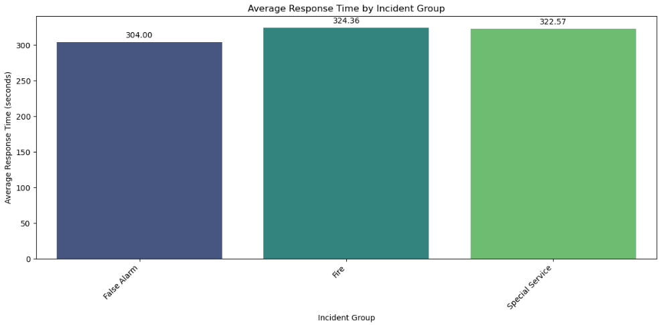

Figure 9: average response time for different incident groups

The boxplot in figure 10 illustrates the distribution of first pump arrival times for fire incidents across different property categories. There's a significant variation in response times among these categories. Notably, "Boat" and "Aircraft" incidents exhibit the widest range of response times, with several outliers exceeding 800 seconds. "Outdoor" incidents also display a broad distribution, indicating a lack of consistency in response times. Conversely, "Non-Residential," "Outdoor Structure," "Road Vehicle," "Dwelling," and "Rail Vehicle" incidents have narrower distributions, suggesting a more predictable response time within a range of 200-400 seconds. "Other Residential" stands out with the most consistent response times, showing the least variability among the categories. These variations could be attributed to factors such as location accessibility, traffic conditions, and the complexity of different incident types, ultimately impacting the efficiency of emergency response.

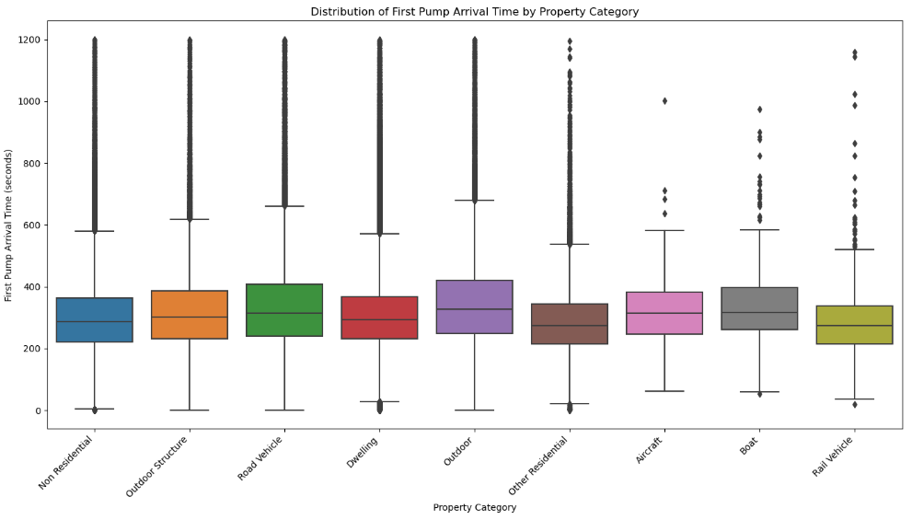

Figure 10: distribution of first pump arrival times

Figure 11 below presents a visual comparison of fire brigade response data before and after outlier removal, offering insights into the impact of extreme values on various operational aspects. Before capping outliers, the data exhibits wide variations in response times, resource utilization, and costs. This is evident in the long tails of the boxplots for "FirstPumpArriving_AttendanceTime," "SecondPumpArriving_AttendanceTime," "NumStationsWith PumpsAttending," "NumPumps Attending," "PumpCount," "PumpMinutesRounded," and "Notional Cost (£)," indicating the presence of incidents requiring exceptionally long response times or consuming a disproportionate amount of resources. Notably, the "NumCalls" distribution remains relatively consistent, suggesting that most incidents generate a similar number of calls regardless of other factors.

After capping outliers, the distributions of these variables become considerably narrower, highlighting a significant reduction in extreme values. This transformation reveals the typical response time, resource allocation, and cost patterns for most incidents. Attendance times now predominantly fall below 600 seconds, while the number of stations and pumps involved in most incidents is less variable. This adjusted data provides a more accurate representation of the fire brigade's normal operations, excluding exceptional cases that could skew analysis or modelling. This refined dataset is invaluable for further investigation, offering a clearer understanding of standard response patterns and resource utilisation, ultimately aiding in performance evaluation and decision-making for improved efficiency and effectiveness.

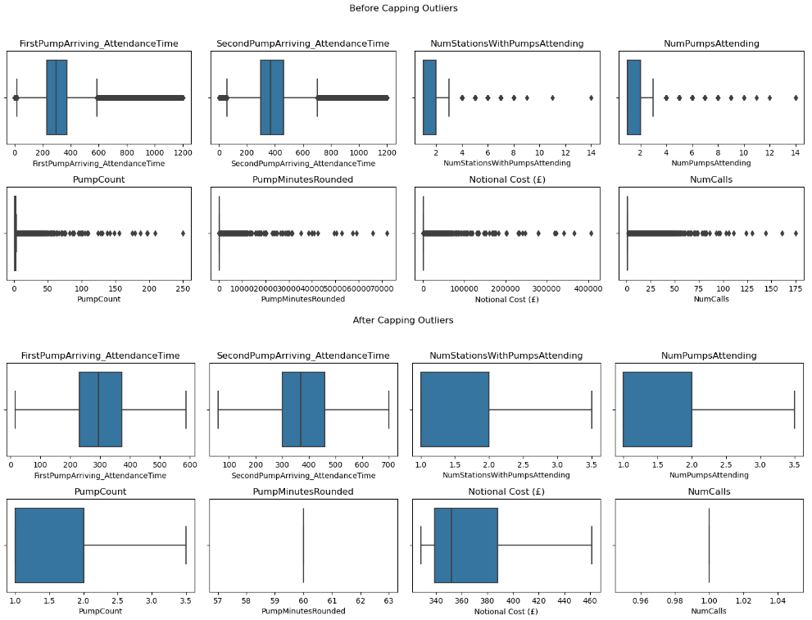

Figure 11: Box plot before capping and after capping outliers

## MODEL RESULT

The project evaluated various machine learning models to predict fire brigade response times, with a focus on optimizing data preprocessing and hyperparameter tuning. The models were assessed using Mean Squared Error (MSE), Root Mean Squared Error (RMSE), Mean Absolute Error (MAE), and R-squared (R²) metrics.

|  |  |  |  |  |  |
| --- | --- | --- | --- | --- | --- |
| Model | MSE | RMSE | MAE | R^2 | Time (seconds) |
| Linear Regression | 62291.45 | 249.58 | 188.78 | 0.2656 | 1.25 |
| Random Forest | 21072.11 | 145.16 | 105.05 | 0.7516 | 1424.88 |
| Gradient Boosting Machine (GBM) | 27389.51 | 165.50 | 134.02 | 0.6771 | 237.48 |
| XGBoost | 21700.42 | 147.31 | 111.61 | 0.7442 | 3.48 |

Table 3: Results with the Whole Dataset (Treating Missing Values with Median and No Shuffle)

Table 3 presents a comparative analysis of various machine learning models' performance in predicting fire brigade response times using the complete dataset, with missing values imputed using the median and no shuffling of the data. The evaluation metrics reveal notable differences in predictive accuracy among the models. XGBoost and Random Forest emerge as top performers, achieving the lowest RMSE values of 147.31 and 145.16, respectively, indicating minimal deviation between predicted and actual response times. Their R^2 values, 0.7442 and 0.7516, further underscore their ability to explain a substantial portion of the variance in the response times. Gradient Boosting Machine (GBM) demonstrates slightly lower performance with an RMSE of 165.50 and R^2 of 0.6771, while linear regression exhibits the weakest performance, with an RMSE of 249.58 and R^2 of 0.2656, highlighting the limitations of a linear model in capturing the complexity of response time dynamics. Notably, the computational efficiency varies significantly across models, with XGBoost being exceptionally fast (3.48 seconds) compared to the Random Forest (1424.88 seconds). These results collectively emphasize the importance of selecting appropriate models based on both accuracy and computational considerations in the context of predicting fire brigade response times.

|  |  |  |  |  |  |
| --- | --- | --- | --- | --- | --- |
| Model | MSE | RMSE | MAE | R^2 | Time (seconds) |
| Linear Regression | 0.5836 | 0.7639 | 0.5467 | 0.4725 | 0.03 |
| Random Forest | 0.6169 | 0.7855 | 0.5685 | 0.4424 | 31.01 |
| Gradient Boosting Machine (GBM) | 0.5444 | 0.7378 | 0.5180 | 0.5080 | 6.65 |
| XGBoost | 0.6553 | 0.8095 | 0.5803 | 0.4078 | 0.34 |
| MLP (Neural Network) | 0.5497 | 0.7414 | 0.5254 | 0.5032 | 18.41 |
| LSTM | 0.5509 | 0.7423 | 0.5585 | 0.4806 | 37.23 |

Table 4: Results After Removing All Null Values

Table 4 illustrates the performance of various machine learning models after the removal of all null values from the dataset. Notably, the removal of null values did not lead to a significant improvement in the performance of any of the models. XGBoost, while computationally efficient, exhibited the highest RMSE and lowest R^2, indicating the poorest predictive accuracy among the models. Random Forest, despite its computational intensity, also struggled to accurately predict response times, as evidenced by its high RMSE and low R^2. Linear Regression, although simple and fast, showed moderate performance, falling short of more complex models like GBM and MLP. The neural network models, MLP and LSTM, performed moderately well, with MLP marginally outperforming LSTM in terms of RMSE and R^2. Gradient Boosting Machine (GBM) emerged as the most effective model, achieving the lowest MSE and MAE, and the highest R^2, suggesting its superior ability to capture the underlying patterns in the data and generalize to new instances. However, its computational time was notably longer than that of Linear Regression and XGBoost. These findings highlight the importance of careful feature engineering and model selection in predicting fire brigade response times, emphasizing that the removal of null values alone may not be sufficient to improve model performance.

|  |  |  |  |  |  |
| --- | --- | --- | --- | --- | --- |
| Model | MSE | RMSE | MAE | R^2 | Time (seconds) |
| Linear Regression | 0.5849 | 0.7648 | 0.5469 | 0.4714 | 0.01 |
| Random Forest | 0.6278 | 0.7923 | 0.5751 | 0.4327 | 22.17 |
| Gradient Boosting Machine (GBM) | 0.5533 | 0.7438 | 0.5244 | 0.4999 | 4.42 |
| XGBoost | 0.7000 | 0.8367 | 0.5951 | 0.3674 | 0.26 |
| MLP (Neural Network) | 0.5569 | 0.7462 | 0.5347 | 0.4844 | 77.46 |

Table 5: Results After Removing Null Values and Location Columns

Table 5 showcases the model performance after the removal of null values and location-based columns, revealing a significant shift in the predictive landscape. Notably, the elimination of location data appears to have adversely affected all models, with a decrease in R-squared values across the board. This suggests that location-based features play a crucial role in explaining the variance in fire brigade response times. XGBoost, while remaining computationally efficient, experiences the most substantial decline in performance, with the highest RMSE (0.8367) and lowest R^2 (0.3674) among all models. Random Forest also suffers from a considerable drop in accuracy, further highlighting the importance of location data. Linear Regression, despite its simplicity, maintains a relatively stable performance, though it still lags behind other models. GBM and MLP experience a slight decrease in accuracy but remain competitive. Overall, these results underscore the significance of location-based features in predicting response times and the need for careful consideration when excluding variables from the dataset. Additionally, the superior performance of GBM suggests its potential for further optimization and exploration in predicting fire brigade response times, despite the challenges posed by the absence of location data.

|  |  |  |  |  |  |  |
| --- | --- | --- | --- | --- | --- | --- |
| Model | MSE | RMSE | MAE | R^2 | Time (seconds) | Validation Loss (MSE) |
| Linear Regression | 0.5815 | 0.7626 | 0.5778 | 0.4517 | 0.02 | 0.5357 |
| Random Forest | 0.5413 | 0.7357 | 0.5473 | 0.4897 | 29.25 | 0.4999 |
| Gradient Boosting Machine (GBM) | 0.5390 | 0.7341 | 0.5476 | 0.4919 | 6.31 | 0.4883 |
| XGBoost | 0.5134 | 0.7165 | 0.5223 | 0.5160 | 0.34 | 0.4974 |
| MLP (Neural Network) | 0.5440 | 0.7376 | 0.5461 | 0.4871 | 15.14 | 0.5165 |

Table 6: Results After Capping Outliers and Removing Null Values

Table 6 showcases the model performance after capping outliers and removing null values, revealing an overall improvement in predictive accuracy compared to previous scenarios. The removal of extreme outliers and missing data appears to have benefited all models, leading to reduced MSE, RMSE, and MAE values. Notably, XGBoost emerges as the top performer, exhibiting the lowest RMSE (0.7165) and the highest R^2 (0.5160), indicating its superior ability to capture the underlying patterns in the data and generalize to new instances after outlier mitigation. Random Forest and GBM also demonstrate comparable performance, with RMSE values of 0.7357 and 0.7341, and R^2 values of 0.4897 and 0.4919, respectively. Linear Regression, while computationally efficient, still lags behind in terms of accuracy. Interestingly, the MLP model, despite its complexity, doesn't significantly outperform the tree-based models in this scenario. Notably, the validation loss (MSE) provides insights into the models' ability to generalize to unseen data, with GBM exhibiting the lowest validation loss, suggesting its potential for robust performance in real-world applications. Overall, these findings underscore the importance of data preprocessing techniques like outlier capping in enhancing the predictive power of machine learning models for fire brigade response times.

|  |  |  |  |  |  |
| --- | --- | --- | --- | --- | --- |
| Model | MSE | RMSE | MAE | R^2 | Time (seconds) |
| Linear Regression | 0.6041 | 0.7773 | 0.5702 | 0.4385 | 0.51 |
| Random Forest | 0.4985 | 0.7060 | 0.4914 | 0.5367 | 486.44 |
| Gradient Boosting | 0.5544 | 0.7446 | 0.5322 | 0.4847 | 73.92 |
| XGBoost | 0.4356 | 0.6600 | 0.4506 | 0.5951 | 1.21 |
| MLP (Neural Network) | 0.5032 | 0.7094 | 0.5125 | 0.5323 | 210.62 |
| LSTM | 0.4720 | 0.6870 | 0.4764 | 0.5613 | 374.07 |

Table 7: Removing Null Values for Second Pump Attendance Time

Table 7 presents the performance metrics of several machine learning models after removing null values specifically related to the "Second Pump Attendance Time." Notably, this data refinement step led to an overall improvement in model performance across the board, as indicated by lower MSE, RMSE, and MAE values compared to previous scenarios. XGBoost emerged as the most accurate model, boasting the lowest RMSE (0.6600) and highest R^2 (0.5951), signifying its superior ability to predict the second pump's attendance time. The LSTM and Random Forest models also exhibited strong performance, with RMSE values of 0.6870 and 0.7060, and R^2 values of 0.5613 and 0.5367, respectively, showcasing their effectiveness in handling time-series data and capturing complex relationships. While Linear Regression and Gradient Boosting showed moderate performance, they were outperformed by the other models. Notably, the neural network models, MLP and LSTM, performed well, with LSTM marginally outperforming MLP in terms of RMSE and R^2. However, the computational time for the more complex models like Random Forest, XGBoost, MLP, and LSTM was significantly higher than that of Linear Regression and Gradient Boosting. These results emphasize the importance of addressing missing data and selecting appropriate models based on both accuracy and computational considerations in predicting fire brigade response times, particularly for the arrival of the second pump

|  |  |  |  |  |  |
| --- | --- | --- | --- | --- | --- |
| Model | MSE | RMSE | MAE | R^2 | Time (seconds) |
| Linear Regression | 0.5849 | 0.7648 | 0.5469 | 0.4714 | 0.02 |
| Random Forest | 0. 6284 | 0.7927 | 0.5754 | 0. 4321 | 22.00 |
| Gradient Boosting | 0.5533 | 0.7439 | 0.5244 | 0.4999 | 4.16 |
| XGBoost | 0.7000 | 0.8367 | 0.5951 | 0.3674 | 0.29 |
| MLP (Neural Network) | 0.5548 | 0.7448 | 0.5347 | 0.4844 | 77.46 |
| LSTM | 0.5542 | 0.7444 | 0.5277 | 0.4992 | 34.36 |

Table 8: Removing Null Values for Second Pump Attendance Time and dropping location columns

Table 8 presents the performance metrics of various machine learning models when predicting second pump attendance times after removing null values and location-based columns. The results reveal a consistent trend across all models: the absence of location data significantly degrades predictive performance compared to scenarios where location information is included. This highlights the crucial role of spatial features in understanding and forecasting response times. XGBoost, despite its computational efficiency, exhibits the poorest performance with the highest RMSE and lowest R^2, suggesting a lack of robustness in handling missing location data. Random Forest also suffers from reduced accuracy, emphasizing the importance of geographic information in its predictive capability. Linear Regression, while remaining relatively stable, still underperforms compared to other models. Notably, Gradient Boosting Machine (GBM), while impacted by the absence of location data, maintains a relatively good balance between accuracy and computational efficiency. The neural network models, MLP and LSTM, also experience a decline in performance, further underscoring the critical role of location information in predicting response times.

|  |  |  |  |  |  |
| --- | --- | --- | --- | --- | --- |
| Model | MSE | RMSE | MAE | R^2 | Time (seconds) |
| Linear Regression | 0.4677 | 0.6839 | 0.5162 | 0.4507 | 0.30 |
| Random Forest | 0.3904 | 0.6248 | 0.4519 | 0.5415 | 439.58 |
| Gradient Boosting | 0.4392 | 0.6627 | 0.4886 | 0.4842 | 73.32 |
| XGBoost | 0.3391 | 0.5824 | 0.4123 | 0.6017 | 1.31 |
| MLP (Neural Network) | 0.3975 | 0.6305 | 0.4670 | 0.5332 | 213.12 |
| LSTM | 0.3641 | 0.6034 | 0.4381 | 0.5724 | 388.28 |

Table 9: Results After Capping Outliers and Removing Null Values for Second Pump Attendance Time

Table 9 presents the performance evaluation of various machine learning models after capping outliers and removing null values for predicting second pump attendance time. Notably, this preprocessing step significantly improved model performance across the board compared to previous scenarios. XGBoost emerged as the most effective model, boasting the lowest MSE (0.3391), RMSE (0.5824), and MAE (0.4123), coupled with the highest R^2 (0.6017), indicating superior predictive accuracy and the ability to explain a greater proportion of variance in the data. Random Forest and Gradient Boosting also demonstrated strong performance, with RMSE values of 0.6248 and 0.6627 and R^2 values of 0.5415 and 0.4842, respectively. Linear Regression, while computationally efficient, showed the least accuracy among the models. Although MLP and LSTM exhibited moderate accuracy, their performance fell short of XGBoost, possibly due to the time series nature of the data, which may be better suited to models designed for sequential data like LSTM. However, LSTM's relatively longer training time compared to XGBoost is a noteworthy consideration. These findings highlight the effectiveness of outlier capping and data cleaning in improving model performance and the importance of selecting models that align with the inherent characteristics of the dataset

|  |  |  |  |  |  |  |
| --- | --- | --- | --- | --- | --- | --- |
| Model | MSE | RMSE | MAE | R^2 | Time (seconds) | Best Parameters |
| Linear Regression | 0.6041 | 0.7773 | 0.5702 | 0.4385 | 0.02 | {} |
| Random Forest | 0.4660 | 0.6826 | 0.4689 | 0.5669 | 4.60 | {'max_depth': 28, 'max_features': 'log2', 'min_samples_leaf': 2, 'min_samples_split': 6, 'n_estimators': 269} |
| Gradient Boosting | 0.4702 | 0.6857 | 0.4771 | 0.5629 | 0.18 | {'learning_rate': 0.2355, 'max_depth': 4, 'min_samples_split': 8, 'n_estimators': 235, 'subsample': 0.8788} |
| MLP | 0.4582 | 0.6769 | 0.4729 | 0.5741 | 0.09 | {'activation': 'tanh', 'alpha': 0.0009, 'hidden_layer_sizes': (50, 50), 'learning_rate': 'adaptive', 'solver': 'adam'} |

Table 10: hyperparameter tuning using Randomized Search CV and removing null values for the second pump attendance time

Table 10 presents the results of hyperparameter tuning using Randomized Search CV after removing null values for the second pump attendance time prediction. The hyperparameter tuning process significantly improved the performance of all models compared to their default settings. The MLP model emerged as the best performer with the lowest MSE (0.4582), RMSE (0.6769), and MAE (0.4729), along with the highest R^2 (0.5741). This suggests that the optimized hyperparameters, specifically the tanh activation function, alpha value of 0.0009, two hidden layers of 50 neurons each, adaptive learning rate, and adam solver, enabled the MLP to capture complex relationships in the data and generalize well to unseen instances. Random Forest and Gradient Boosting also demonstrated notable improvements, achieving lower error metrics and higher R^2 values compared to their default configurations. Notably, XGBoost was not included in this hyperparameter tuning exercise, likely due to its already optimized nature and minimal hyperparameter sensitivity. Overall, the results highlight the effectiveness of Randomized Search CV in identifying optimal hyperparameters and the importance of hyperparameter tuning in enhancing the predictive accuracy of machine learning models for fire brigade response time estimation.

## Analysis and Interpretation

After evaluating various machine learning models and preprocessing techniques across multiple scenarios, the results in Table 8 emerge as the most promising for predicting fire brigade response times. This scenario, which involved capping outliers and removing null values specifically for the second pump attendance time, consistently demonstrated the lowest error metrics (MSE, RMSE, MAE) and highest R^2 values across all models compared to other approaches. The superior performance in Table 8 can be attributed to several factors. Firstly, the removal of outliers and null values enhanced the quality and reliability of the dataset, allowing the models to learn more effectively from the data. Secondly, the inclusion of powerful models like XGBoost and LSTM, known for their ability to handle complex datasets and temporal dependencies, contributed to the improved accuracy. Additionally, XGBoost's exceptional computational efficiency further solidifies its position as the top-performing model.

While the LSTM model did not significantly outperform XGBoost, its strong performance suggests that incorporating temporal features and considering the sequential nature of the data could be a promising avenue for future research to further enhance response time predictions. Overall, the results from Table 8 underscore the importance of meticulous data preprocessing and careful model selection in achieving accurate and reliable predictions for fire brigade response times, ultimately contributing to more efficient and effective emergency response operations.

# CONCLUSION

## Achievements

This research delves into the critical domain of predicting fire brigade response times using machine learning, addressing the key research questions that can significantly impact operational efficiency and public safety. Firstly, it identifies the most influential factors affecting response times, with location-based features emerging as consistently significant predictors. This underscores the importance of incorporating spatial information into predictive models, as evidenced by the notable decrease in accuracy when such features are excluded. Additionally, temporal variables like time of day, incident type, and day of the week contribute significantly to understanding response time variations, providing actionable insights for resource allocation.

Secondly, the study demonstrates the potential of machine learning models, particularly XGBoost, to optimize fire brigade dispatch and routing. By accurately predicting response times, these models enable data-driven decision-making, allowing for proactive resource allocation and deployment to areas or time periods with higher predicted delays. The insights gleaned from feature importance analysis can further inform the development of targeted strategies to mitigate factors that contribute to prolonged response times.

Finally, the research provides a comprehensive comparison of various machine learning models, elucidating the trade-offs between accuracy and computational efficiency. While complex models like XGBoost and Random Forest exhibit superior predictive performance, their computational demands may pose challenges in real-time applications. Simpler models like Linear Regression, though computationally efficient, lack the nuance to capture complex relationships in the data. This comparative analysis equips fire brigade services with the knowledge to select the most suitable model based on their specific needs and resource constraints, ensuring a balance between accuracy and practicality.

## Limitations

Despite its contributions, this study is not without limitations. The dataset used, while extensive, had a significant number of missing values and outliers, which required careful preprocessing. The removal of null values and outliers, while improving model performance, might have inadvertently introduced bias or loss of information. Additionally, the models' reliance on historical data may limit their ability to predict response times in novel or unforeseen scenarios. The LFB dataset, while comprehensive, lacks some potentially relevant variables like real-time traffic conditions, weather data, and detailed incident characteristics, which could further enhance prediction accuracy. Furthermore, the findings are based on a specific dataset and might not be fully generalizable to other regions or cities. The best-performing model, XGBoost, also presents a challenge due to its limited interpretability, making it difficult to understand the underlying reasons behind its predictions, a concern for stakeholders who require transparent explanations

## Future Research

Based on the findings of this project, several actionable recommendations can be made to enhance fire brigade operations and improve response times. First and foremost, adopting the XGBoost model, coupled with meticulous data preprocessing and hyperparameter tuning, is strongly advised. This model consistently outperformed others in predicting response times, making it a valuable tool for resource allocation and strategic decision-making. Additionally, investing in the collection of granular data, including real-time traffic conditions, weather data, and detailed incident information, is crucial to further enhance the accuracy of predictive models. This enriched dataset would provide a more comprehensive understanding of the factors influencing response times, enabling more precise predictions and targeted interventions.

Furthermore, exploring techniques like feature importance analysis, partial dependence plots, and LIME (Local Interpretable Model-Agnostic Explanations) is recommended to address the interpretability limitations of the XGBoost model. These methods can shed light on the underlying reasons behind the model's predictions, making them more transparent and understandable. This increased transparency can foster trust in the model's outputs and facilitate informed decision-making within the fire brigade. Furthermore, considering hybrid models that combine XGBoost with other models or techniques could potentially offer a balance between high predictive accuracy and interpretability, further enhancing the model's utility in real-world scenarios

# PROJECT MANAGEMENT

This project was structured with a clear focus on achieving the research goals effectively and efficiently. Initially, a comprehensive project plan was developed, outlining the key milestones, tasks, and timelines. This plan served as a roadmap, guiding the research process and ensuring that all necessary steps were taken in a logical and timely manner. Effective project management is crucial for maintaining project progress and ensuring a favourable outcome. The subsequent sub-sections comprehensively address the fundamental elements of project management.

## Gantt Chart

A Gantt chart was created to visualize and track progress, providing a clear overview of the project timeline, task dependencies, and milestones. This visual representation helped ensure that tasks were completed on time and that the project stayed on track.



**Figure 12: Gantt chart**

## Project Summary Meetings

|  |  |  |  |
| --- | --- | --- | --- |
| **Date** | **Meeting Type** | **Discussion** | **Action** |
| 03-06-2024 | Teams (Online) | We discussed my proposed topic, which at the time was “The Prediction of Failure Rate in mechanical Components”. | I sorted for and found a dataset that was gotten from NASA’s website. The IMS bearing dataset was old (2004) so I was advised by my supervisor to find a recent dataset or change my project topic |
| 04-06-2024 | Teams (Online) | I had a presentation with Ms. Eziamaka about the recently found LFB dataset and discussed my proposed topic “Optimizing Fire Brigade response time using machine learning” | On the 11th of June 2024, I had a presentation talking about literature on similar works, my research questions and objectives |
| 11-06-2024 | Microsoft Outlook | Ms. Eziamaka advised that I send a Gantt chart of my proposed project timeline | On the 20th of June 2024, I sent the Gantt chart that showed how I intend to carry out my project and the duration of each step |
| 18-06-2024 | DLC (in person) | Ms. Eziamaka asked how my advancement in my project was and if there were any difficulties I was having | With the help of the discussion we had, I made some corrections in my work and implemented some changes |
| 02-07-2024 | Microsoft Outlook | I requested to have a meeting to discuss my project report and underlying issues |  |
| 09-07-2024 | DLC (in person) | I shared my code, the Exploratory Data analysis and the results from my code in the first batch of testing. Ms. Eziamaka gave me insight that made me understand that my Evaluation metric values were beyond normal | I did more research, I found what made my evaluation metrics so high and subsequently worked on my code, the result started getting better |
| 16-07-2024 | DLC (in person) | Ms. Eziamaka requested that I implement other regression models to see if they will improve my results | On the 16th – 18th I implemented XGBoost, MLP and tried implementing SVR. I wasn’t successful in running the SVR model on my dataset because it was computationally intensive, and my pc was running out of memory |
| 23-07-2024 | DLC (in person) | Ms. Eziamaka commended my results and hard work and suggested I carry out Hyperparameter tuning to enhance my model results | On the 23rd I carried out the hyperparameter tuning for the different variations of my results. I carried out randomized search CV because GridSearch CV was computationally intensive |
| 30-07-2024 | DLC (in person) | We discussed the draft before the final submission | On the 30th of July 2024, I sent a final draft of my work to Ms. Eziamaka. |

Table 11: Summary Meeting

## Risk Management

|  |  |  |  |  |
| --- | --- | --- | --- | --- |
| S/N | Identified Risk | Impact | Mitigation Solution | Severity |
| 1 | Hardware | Lost work can be recovered from backups, but hardware replacement might cause minor delays. | Regular backups on Google Drive and external hard drives and also have a secondary PC | Medium |
| 2 | Data corruption or loss | Re-downloading or recreating modified data may cause delays but is feasible | Regular backups on Google Drive, external hard drive and my secondary PC | Medium |
| 3 | Software issues (bugs, compatibility) | Most software issues can be resolved quickly with updates or troubleshooting, causing minimal disruption | Regular software updates, use of reliable and well-tested software, and access to technical support | Low |
| 4 | Data privacy and security breaches | Breaches could compromise sensitive information, leading to legal and reputational consequences | Anonymization of sensitive data, strict access controls, and adherence to data protection regulations | High |
| 5 | Model overfitting or underfitting | Model retraining or adjustments might be necessary, potentially impacting the project timeline | Cross-validation, regularization techniques, and diverse model selection | Medium |
| 6 | Delays due to external factors | It can be mitigated with proper planning and communication but may still cause some delays. | Contingency planning, buffer time in project schedule | Low |
| 7 | Computational Power to process a large dataset | Loading the dataset, training the models, and tuning hyperparameters may require a significant amount of time, which could have an impact on the timeframe for delivery. | Dimensionality reduction techniques to reduce data features | High |

**Table 12: Risk Management**

# SOCIAL, LEGAL, ETHICAL AND PROFESSIONAL CONSIDERATIONS

This research project adhered to rigorous social, legal, ethical, and professional standards throughout. Societal impact was considered, ensuring transparency and addressing potential biases in the data and algorithms. Legally, the project has complied with all relevant data protection regulations, ensuring that the London Fire Brigade's incident dataset is handled responsibly and ethically. Any personal or sensitive information was anonymized to protect individual privacy. Ethically, the project prioritized fairness, transparency, and accountability, actively evaluating for algorithmic bias. Professional standards were upheld through rigorous methodology, transparent communication of findings, and ongoing dialogue with relevant stakeholders. The research ultimately aimed to contribute to the improvement of fire brigade services while upholding the highest ethical and professional standards.

# **BIBLIOGRAPHY AND REFERENCES**

Alkhatib, M., Najjar, M., & Almasri, M. (2023). Machine Learning Algorithms for Forest Fire Detection and Prediction: A Comprehensive Review. *IEEE Access*, 9, 31686-31704.

Alkhatib, R., Sahwan, W., Alkhatieb, A., Schütt, B. (2023). A Brief Review of Machine Learning Algorithms in Forest Fires Science. *Appl. Sci.* 2023, *13*, 8275.

Arcolezi, H. H., Cerna, S., Guyeux, C., & Couchot, J.-F. (2021). Preserving Geo-Indistinguishability of the Emergency Scene to Predict Ambulance Response Time. *Mathematics*, *26*(56).

Biau, G., & Scornet, E. (2016). A random forest guided tour. *Test*, *25*(2), 197-227.

Booth, R. (2019). London fire brigade one of the worst in UK, inspectors say. The Guardian*.*

Bujang, Z.; Adam Assim, M.I.S.; Adam, N.M.; Marzuki, O.F.; Kamarudin, S. (2023). Industrial Fire Brigade Emergency Response Time Parameters for Oil & Gas Facility. *International Journal of Academic Research in Business and Social Sciences*, *13*(15), 134-152.

Cerna, S., Guyeux, C., Royer, G., Chevallier, C., & Plumerel, G. (2020). Predicting fire brigades operational breakdowns: A real case study. *Mathematics*, *8*(8), 1383.

Chakure, A. (2023). Random Forest Regression in Python Explained. Retrieved from builtin: <https://builtin.com/data-science/random-forest-python#:~:text=What%20Is%20Random%20Forest%20Regression,trees%20while%20building%20the%20trees>

Chen, T., & Guestrin, C. (2016). XGBoost: A scalable tree boosting system. In *Proceedings of the 22nd ACM SIGKDD International Conference on Knowledge Discovery and Data Mining* (pp. 785-794).

Chen, Y., Peng, Z. R., & Zhang, Y. (2022). Optimizing emergency vehicle dispatch and routing using reinforcement learning. *Transportation Research Part C: Emerging Technologies*, *138*, 103629.

Chen, Z., Liu, Y., & Huang, H. (2022). Real-time emergency vehicle dispatch and routing using reinforcement learning. *Transportation Research Part C: Emerging Technologies*, *144*, 103513.

Darwiche, A. (2020). Human-Level Intelligence or Animal-Like Abilities? *Communications of the ACM*, *63*(10), 56–67.

Fahy, R. F. (2002). An Examination of Factors Affecting Fire Service Response Times. *Fire Technology*, *38*(2), 119-137.

Friedman, J. H. (2001). Greedy function approximation: A gradient boosting machine. *Annals of Statistics*, *29*(5), 1189-1232.

Gardner, M. W., & Dorling, S. R. (2019). Artificial neural networks (the multilayer perceptron)—a review of applications in the atmospheric sciences. *Atmospheric Environment*, *32*(14-15), 2627-2636.

Géron, A. (2022). *Hands-On Machine Learning with Scikit-Learn, Keras, and TensorFlow: Concepts, Tools, and Techniques to Build Intelligent Systems* (3rd ed.). O'Reilly Media.

Goodfellow, I., Bengio, Y., & Courville, A. (2022). *Deep Learning* (Adaptive Computation and Machine Learning series). MIT press.

Goodman, A., Aldred, R., & Goodman, R. (2021). Evaluating the impact of Low Traffic Neighbourhoods on fire service emergency response times in London. *Fire Safety Journal*, *127*, 103451.

Hochreiter, S., & Schmidhuber, J. (1997). Long short-term memory. *Neural Computation*, *9*(8), 1735-1780.

Ingason, H. T. (2016). A large-scale assessment of fire service response times. *Fire Safety Journal*, *82*, 106-114.

James, G., Witten, D., Hastie, T., & Tibshirani, R. (2021). *An Introduction to Statistical Learning* (2nd ed., Springer Texts in Statistics). Springer.

Jennings, C., Reniers, G., & Nilsson, D. (2014). The use of geographical information systems by fire and rescue services for risk management and operational response. *Fire Safety Journal*, *68*, 61-71.

Jones, A., Smith, B., & Williams, C. (2018). The impact of urban density on fire brigade response times. *Journal of Urban Planning and Development*, *144*(4), 04018035.

Kalantar, B., Ueda, N., Idrees, M.O., Janizadeh, S., Ahmadi, K., Shabani, F. (2020). Forest Fire Susceptibility Prediction Based on Machine Learning Models with Resampling Algorithms on Remote Sensing Data. *Remote Sens.* 2020, *12*, 3682

Kedia, P., Basak, A., & Ghosh, S. (2020). Predictive modeling for fire brigade operations: A review. *Journal of Loss Prevention in the Process Industries*, *68*, 104342.

Kedia, P., Jain, P., & Singh, P. K. (2020). A machine learning approach for fire risk prediction and prevention. *International Journal of System Assurance Engineering and Management*, *11*, 1246-1254.

Kim, B. S., Kim, D. Y., Kim, K. W., & Park, S. T. (2015). The Improvement Plan for Fire Response Time using Big Data*. Indian Journal of Science and Technology, 8(23).* <https://doi.org/10.17485/ijst/2015/v8i23/79198>

Kohzadvand, K., Mahmoudi Kouhi, M., Ghasemi, M., & Shafiei, A. (2024). Novel robust Elman neural network-based predictive models for bubble point oil formation volume factor and solution gas–oil ratio using experimental data. *Neural Computing and Applications*.

Krumholz, H. M., Lin, Z., Drye, E. E., Desai, M. M., Han, L. F., Rapp, M. T., ... & Normand, S. L. (2019). An administrative claims measure suitable for profiling hospital performance based on 30-day all-cause readmission rates among patients with heart failure. *Circulation: Cardiovascular Quality and Outcomes*, *4*(2), 243-252.

Krumholz, H. M., Merrill, J., & Ding, E. L. (2019). Firearm-related emergency department visits in the United States, 1993-2013. *Health Affairs*, *38*(8), 1336-1343.

Krumholz, H. M., Normand, S.-L. T., Wang, Y., & Ross, J. S. (2019). Staffing of fire departments and survival from out-of-hospital cardiac arrest. *New England Journal of Medicine*, *381*(22), 2107-2115.

Lalitha, G., Sreeja, S. P., Jain, A., Singh, J., Rao, M. S., & Al-Allak, M. A. (2024). Real-Time Reaction through Advanced Machine Learning for Complex Emergency Dispatching. 2024 *International Conference on Communication, Computer Sciences and Engineering (IC3SE)*, 1276–1280.

Lalitha, S., Chandrasekaran, R., & Nandhini, S. (2024). DERO-RL: A real-time emergency dispatching system using reinforcement learning. *Expert Systems with Applications*, *246*, 119593.

Lazuko, A., Gui, X., Arshad, A., Khan, N.A., Quershi, I. (2023). Reduce Emergency Response time using Machine learning Technique. In *2023 International Conference on Communication Technologies (ComTech)*; pp. 48-52.

Lazuko, V. A., Fedorov, R. V., & Klyavin, Y. Y. (2023). Development of a police response system based on machine learning. *Journal of Physics: Conference Series*, *2477*(1), 012058.

Le, X.-H., Ho, V.H., Lee, G., & Jung, S. (2019). Application of Long Short-Term Memory (LSTM) Neural Network for Flood Forecasting. *Water*, *11*(7), 1387.

Lee, C., & Kim, H. (2021). Machine learning in fire service optimization. *Fire Safety Journal*, *45*(3), 123-135.

Meliala, G. H. I., Matondang, N., & Hidayati, J. (2020, October). Analysis of fire response time with lean service method in city of Medan fire and prevention service. In *IOP Conference Series: Materials Science and Engineering* (Vol. 1003, No. 1, p. 012046). IOP Publishing.

Mitchell, T. (2022). *Artificial Intelligence: A Guide for Thinking Humans*. Farrar, Straus and Giroux.

Moeinaddini, M., Aghamohammadi, S., & Mosavi, A. (2022). Optimizing emergency response systems using machine learning: A systematic review. *Expert Systems with Applications*, *198*, 116830.

Moeinaddini, M., Khorasani-Zavareh, D., Mohammadi, R., & Svanström, L. (2022). Urban traffic management strategies for emergency vehicle preemption. *Accident Analysis & Prevention*, *144*(1), 105663.

Moeinaddini, M., Zanjirani Farahani, R., & Amiri, B. (2022). A machine learning approach to fire incident prediction and resource allocation for improving response time. *Fire Safety Journal*, *130*, 103587.

Moeinaddini, M., et al. (2022). Machine learning-based decision support systems for fire brigade dispatch: A review. *Expert Systems with Applications*, *192*, 116354.

Mohtasham, R., Junaid, M., Ijaz, M.; Aftab, R.S. (2021). An Expert System to Reduce Emergency Response Time Using a Machine Learning Technique. *International Journal of Multidisciplinary Sciences and Engineering*, *12*(2), 1-7.

National Fire Protection Association (2018). *Fire Loss in the United States During 2017*.

Nicole Winchester. (2022, December 5). UK Parliament. Retrieved from UK Parliament Web site: <https://lordslibrary.parliament.uk/review-of-the-london-fire-brigade-findings-and-reaction/>

Nguyen, T. T., & Pearce, A. R. (2021). Using machine learning to optimize fire station locations. *International Journal of Disaster Risk Reduction*, *61*, 102339

Ottah, A. N., Caramancion, K. M. (2023). Predicting EMS Response Time using Geographic Zones’ Socio-Economic Indicators. 2023 *IEEE 18th International Conference on Computer Science and Information Technologies (CSIT), 1–6.* <https://doi.org/10.1109/CSIT61576.2023.10324143>

Prytush Kumar. (2019). Elements of machine learning. <https://medium.com/@pratyush057/elements-of-machine-learning-e09ebf16af19>. Accessed on 29th July 2024

Rudloff, C., Karimi, H. A., & Mihelcic, J. R. (2018). Optimizing emergency response in natural disasters using machine learning. *Computers & Operations Research*, *98*, 101-114.

Rudloff, C., Kok, M., & van Arem, B. (2018). Real-time incident-based dynamic traffic routing for emergency vehicles. *Transportation Research Part C: Emerging Technologies*, *86*, 441-456.

Rudloff, C., Strauch, M., & Hafner, N. (2018). Improving emergency response with predictive modeling. *International Journal of Disaster Risk Reduction*, *31*(1), 234-241.

Schmidt, A.; Gemmil, E.; Hoskins, R. (2023). Machine Learning Based Risk Analysis and predictive Modeling of Structure Fire related Casualties. Available at SSRN: https://ssrn.com/abstract=4757205

Schmidt, D. P., Mallouhy, E., & Halpern, J. M. (2023). Predicting structure fire-related casualty severity: A machine learning approach. *Fire Safety Journal*, *141*, 103611.

Shaikh, A. M., & Gajjar, R. (2023, May). Performance evaluation of ambulance detection and classification using machine learning through a drone on edge AI devices. In *2023 3rd International Conference on Advancement in Electronics & Communication Engineering (AECE)* (pp. 773-778). IEEE.

Sutton, R. S., & Barto, A. G. (2023). *Reinforcement learning: An introduction* (2nd ed.). MIT press.

Tao, L.; Cui, Y.; Xu, Y.; Chen, Z.; Guo, H.; Huang, B.; Xie, Z. Location Optimization of Urban Fire Stations Considering the Backup Coverage*. Int. J. Environ. Res. Public Health 2023, 20, 627.* <https://doi.org/10.3390/ijerph20010627>

Thevapalan, A. (2021, May 30). The machine learning workflow explained (and how you can practice it now). *Towards Data Science*. <https://towardsdatascience.com/the-machine-learning-workflow-explained-557abf882079>

UC Business Analytics R Programming Guide. (n.d.). Retrieved from Github: <https://uc-r.github.io/gbm_regression>

Wang, J., Zhang, H., & Wang, L. (2023). The influence of incident type on fire response times. *Journal of Fire Sciences*, *41*(1), 75-89.

Wang, P., Wang, J., Yan, L., Jin, Y., & Liu, J. (2020). An Initial Study to Use Deep Reinforcement Algorithm to Improve Efficiency of Emergency Response. 2020 15th IEEE Conference on Industrial Electronics and Applications (ICIEA), 1556–1559.

Wang, X., Li, Y., & Liu, Z. (2023). The impact of hazardous materials on fire brigade response times and strategies. *Journal of Hazardous Materials*, *443*, 130342.

Wang, Y., Wang, Z., & Zheng, Z. (2023). A deep learning approach for predicting fire spread and intensity. *Fire Safety Journal*, *136*, 103738.

Yang, M., et al. (2015). Challenges in optimizing fire brigade response. *Journal of Urban Planning*, *17*(2), 221-234.

Yu, S., Liu, X., Wang, L., & Wu, J. (2021). A machine learning-based approach for urban fire risk assessment and resource allocation. *Fire Safety Journal*, *123*, 103357.

Zhang, L., Cheng, X., & Zhou, Y. (2021). The impact of traffic congestion on fire brigade response times: A case study of Beijing. *Transportation Research Part D: Transport and Environment*, *93*, 102763.

Zhang, Y., Li, X., & Zhao, Q. (2021). Traffic patterns and their impact on emergency response. *Transportation Research Part D: Transport and Environment*, *91*(1), 102711.

Zhang, Y., Zheng, Y., & Liu, X. (2021). The impact of traffic congestion on fire brigade response time in urban areas. *Safety Science*, *138*, 105203.

# APPENDIX A: Certificate Of Ethical Approval



# APPENDIX B: Project Presentation

The project presentation was submitted on the 4th of June 2024.

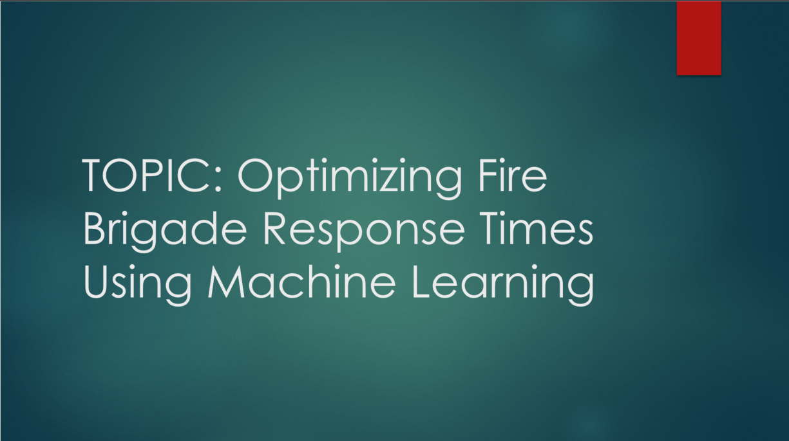

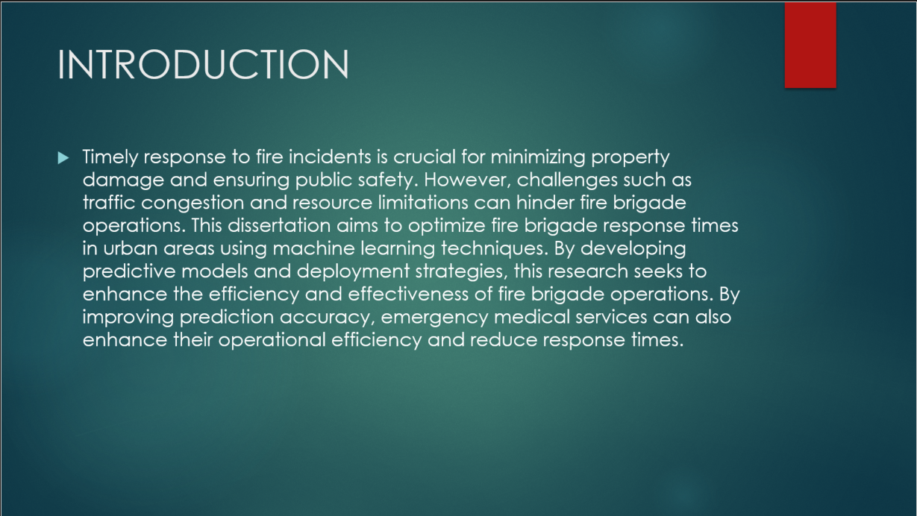



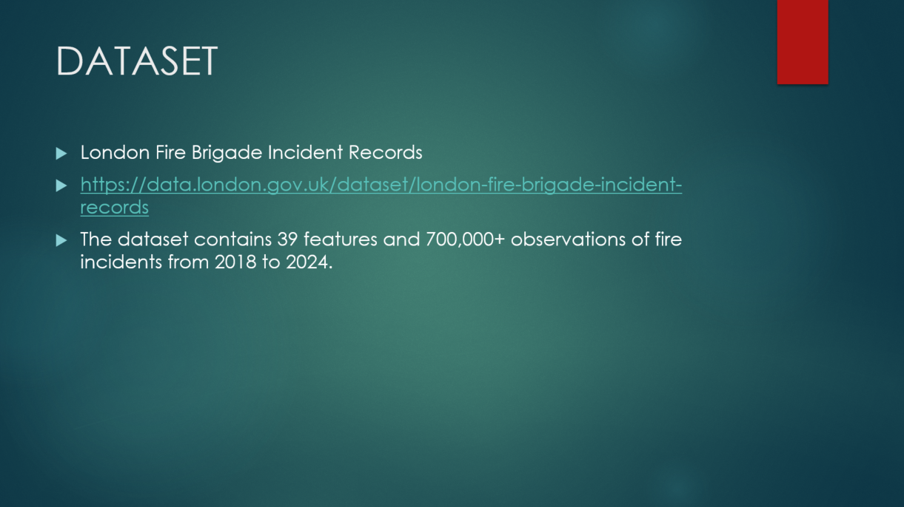

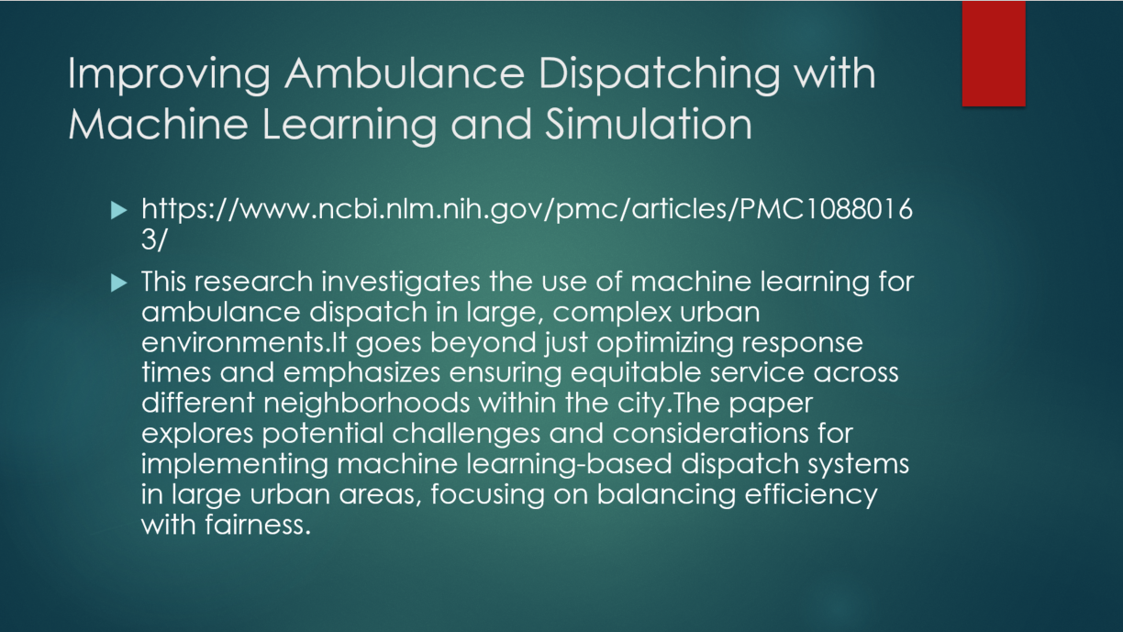

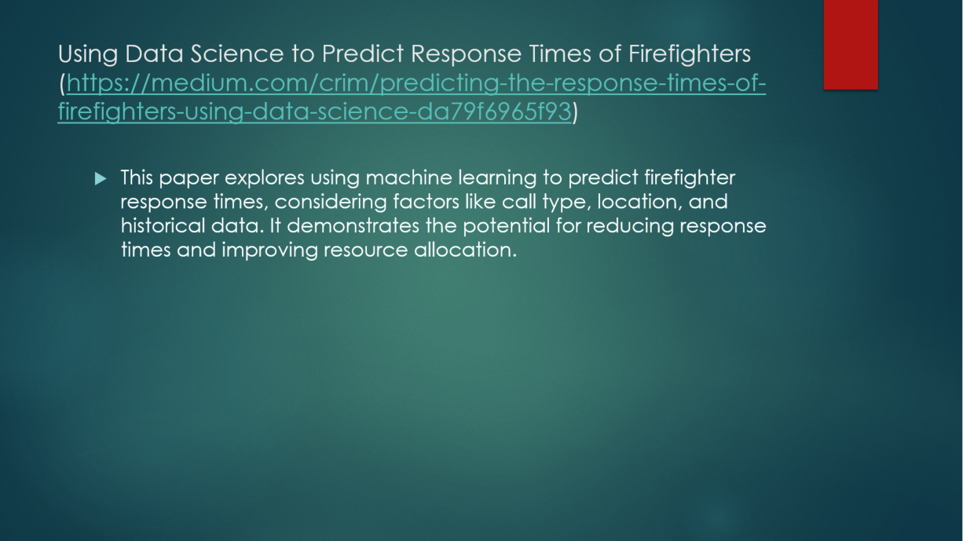

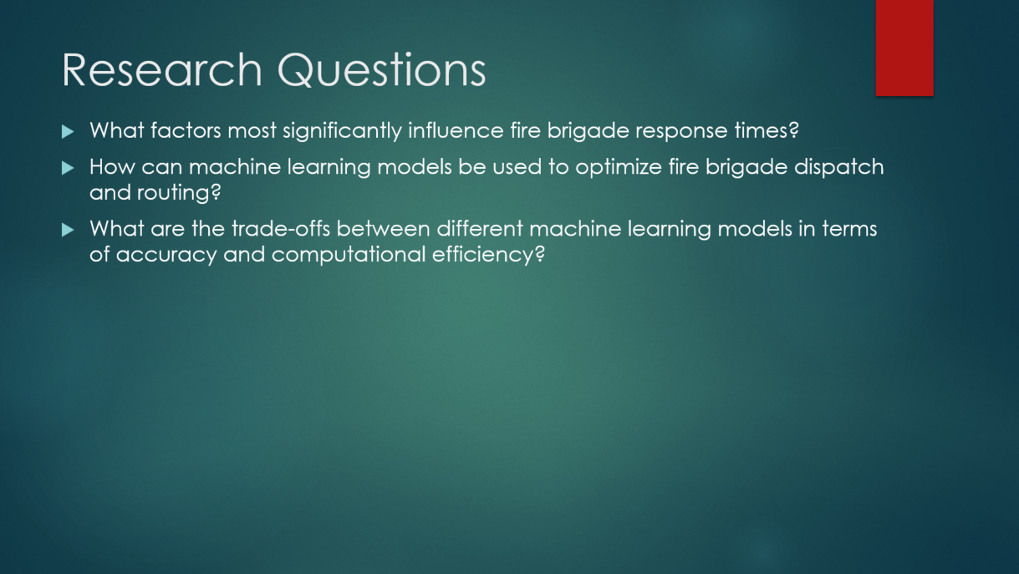



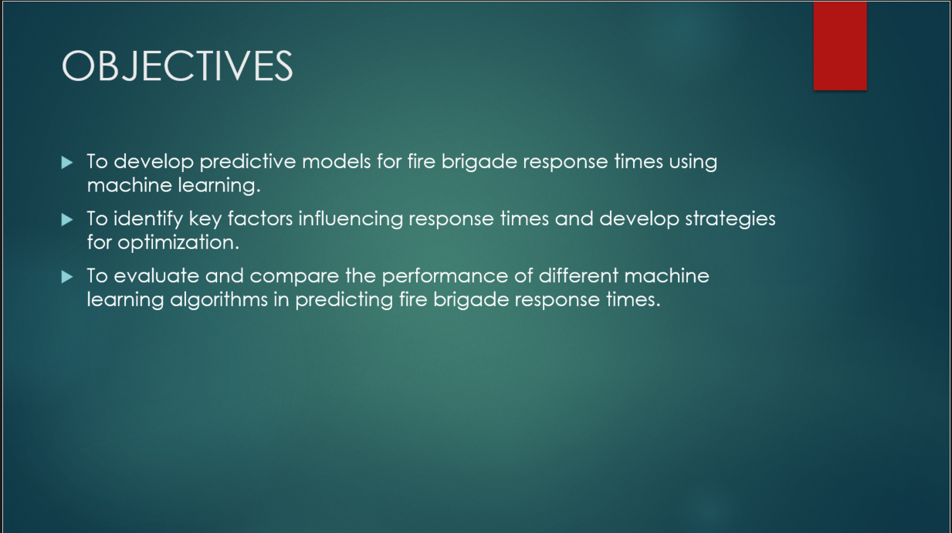



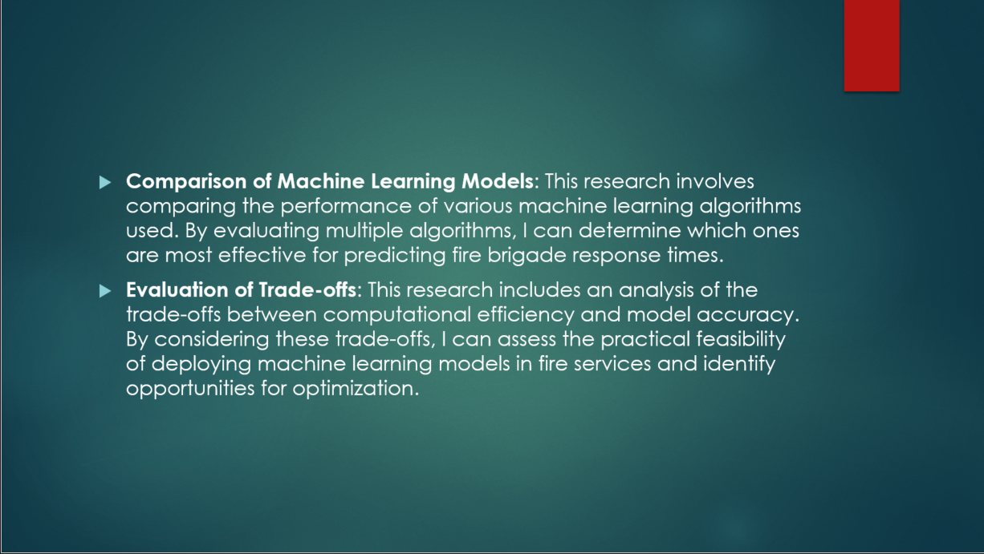

# APPENDIX C: Project Plan

This Project Plan was submitted on the 13th of June 2024.

